PedPDX:
The PedPDX Mission
Through PedPDX, the City of Portland affirms walking as a fundamental human right and the most fundamental means of transportation.
PedPDX ensures walking is a safe, accessible, and attractive experience for everyone in Portland by putting
pedestrians at the forefront of City policy, investments, and design.
Portland’s Citywide Pedestrian Plan

What is PedPDX?
PedPDX is Portland’s citywide pedestrian plan. It prioritizes sidewalk and crossing improvements and other investments to make walking safer and more comfortable across the city. The plan identifies the key strategies and tools we will use to make Portland a great walking city for everyone.

HOW WE GOT HERE:
After two years of study and collaboration with our community partners, the Portland Bureau of Transportation is ready to showcase PedPDX.
A public review draft is available starting March 4th and the comment period will be open until May 3rd. Your input is important to us and
will help us shape PedPDX for the better before it goes to City Council for approval this June.

PROJECT KICKOFF
Summer 2017

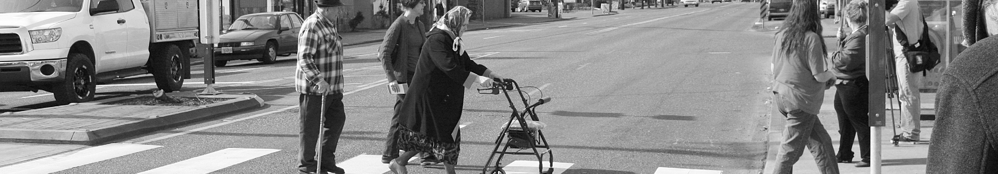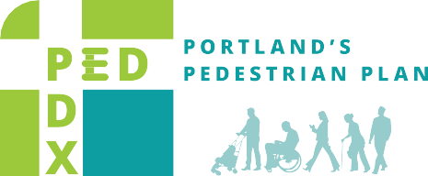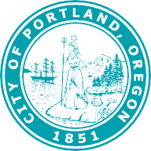

PEDTRIAN POLICY & PROGRAM REVIEW
Fall 2017

SAFETY ANALYSIS
Winter 2018

PRIORITY NETWORK & NEEDS ANALYSIS
Spring/Summer 2018

TOOLBOX DEVELOPMENT
Fall 2018

DRAFT PUBLIC REVIEW PLAN
Winter/Spring 2019
WALKING PRIORITIES SURVEY
Summer/Fall 2017

MISSION, VISION & GOALS
Winter 2017-2018

WALKING STORIES
Winter/Spring 2018

NEEDS PRIORITIZATION
Summer/Fall 2019

PERFORMANCE MEASURES

The City of Portland is committed to providing meaningful access.
To request translation, interpretation, modifications, accommodations, or other auxiliary aids or services, contact
503-823-5282, Relay: 711.
Fall/Winter 2019

CITY COUNCIL ADOPTION
Early Summer 2019

PedPDX Community Advisory Committee members share their walking stories and vision for making Portland a great walking city at a committee meeting in January 2018.
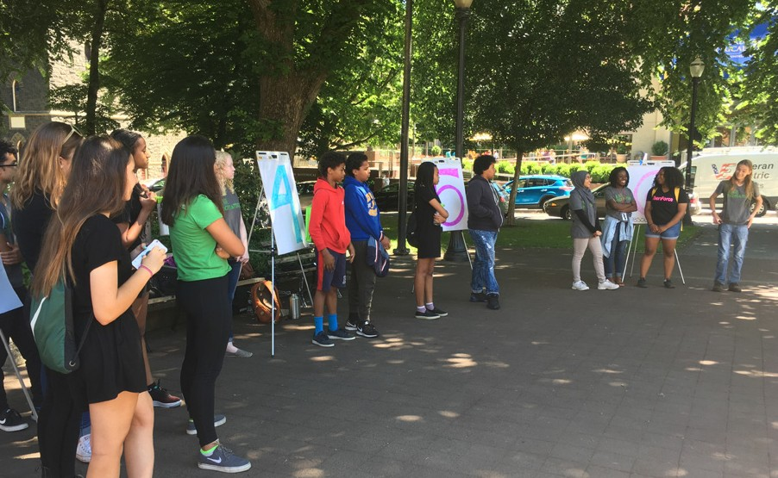
Over twenty students participating in the City of Portland Teen Force Program shared their barriers to walking in an interactive activity as part of the Walking Priorities survey.

Key Elements of PedPDX

PEDESTRIAN STREET CLASSIFICATIONS
Pedestrian Districts Major City Walkways City Walkways Neighborhood Walkways

PedPDX introduces new street classifications and updates the City of Portland’s Transportation System Plan to reflect where walking infrastructure is most in demand.
A The Pedestrian Priority Network
The Pedestrian Priority Network is the network of Portland streets and paths that provide important connections for people walking to key transit and land use destinations. Each of the streets within the PedPDX Pedestrian Priority Network is categorized based
on how much it demand there is for walking. These demand-based classifications are directly informed by community input from the PedPDX Citywide Walking Priorities Survey.

SIDEWALK GAPS ON MAJOR STREETS
B Identifying and Prioritizing Needs
The PedPDX prioritization framework will guide pedestrian investments. It is based on the factors Portland residents say are most important to them: Equity, Pedestrian Demand, and Safety. PedPDX identifies priority locations for pedestrian investment within the Pedestrian Priority Network using a data-based approach.
This approach helps ensure we are directing limited resources to the greatest needs first and allows us to provide a proactive, programmatic approach for addressing pedestrian infrastructure needs.

50%
Walkway present on both sides of roadway

8%
One side has a gap, but may meet alt. criteria
32%
Walkway missing on both sides

10%
Gap on one side of the roadway

Today many of the city’s arterials and collectors are missing pedestrian infrastucture. PedPDX identifies these deficiencies and prioritizes how the city should invest future resources.
C PedPDX Implementation Toolbox
The PedPDX Implementation Toolbox is the programmatic work plan to advance the vision and mission of PedPDX. The Toolbox is based on citywide feedback from a variety of outreach efforts including the PedPDX Walking Priorities Survey, equity focus groups, a robust safety analysis, and the PedPDX Community Advisory Committee. It
is organized by strategies and actions, and will guide the work of the City’s pedestrian-related programs and activities. The toolbox is a shared work plan articulating the key actions and tools we will use to implement PedPDX.
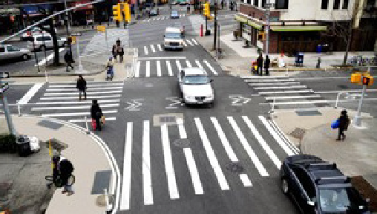
High-visibility crosswalk markings (pictured above) are among one of the many tools, strategies, and designs included in the PedPDX Toolbox.

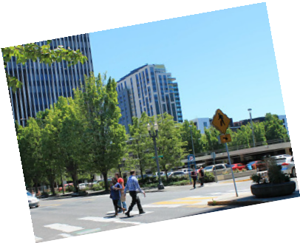DRAFT PLAN AVAILABLE FOR COMMENT.
VISIT PEDPDX.COM TO
- WATCH PLAN OVERVIEW VIDEOS
- REVIEW THE DRAFT PLAN
- SHARE FEEDBACK BY TAKING A SURVEY
Hard copies of PedPDX are over 300 pages and are available upon request. To request a copy, email PedPDX@portlandoregon.gov or call 503.823.5282.

TWO MONTH PUBLIC COMMENT WINDOW OPEN UNTIL:

MAY 3

