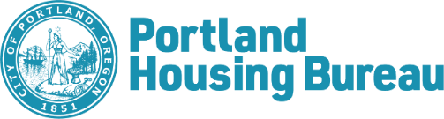
Form A
Sponsor Cover Page
2021 Metro Bond Opportunity Solicitation
Sponsor Name:
Sponsor Contact Person

Contact Information

Unit Type* | # of Units | Proposed MFI | Proposed Rent per month | Project Based Section 8 request Yes/No
SRO
SRO
Studio
Studio
1 Bed
1 Bed
2 Bed
2 Bed
3 Bed
3 Bed
4 Bed
Total
Unit and Income Mix Table
*Insert/delete rows as needed

This proposal is submitted pursuant to the General Conditions listed in Section X of the 2021 Metro Bond Opportunity Solicitation (M-BOS). The Sponsor, the Development Team, and their representatives, hereby, agree to comply with all terms under the General Conditions.

Signature / Title Date
To be signed by Executive Director or equivalent

