Mitigation Action Strategy

Introduction
The Mitigation Action Strategy is the heart of the MAP; it brings together the findings of the risk assessment, community engagement, and the expertise of the Steering Committee and stakeholders to describe the mitigation work the City will take on over the next five years. The Mitigation Action Strategy includes projects within the FEMA defined categories of mitigation work: Local Plans and Regulations, Structure and Infrastructure Projects, Natural Systems Protection, and Education and Awareness Programs.

Developing the Strategy
The strategy was largely developed by the Steering Committee, with input from key stakeholders. Steering Committee members were responsible for gathering feedback from colleagues, City leadership, and collaborators outside the City regarding proposed projects. These stakeholders often included leaders and supervisors who are responsible for individual bureau budgets and strategic priorities.

The first step to developing the Mitigation Action Strategy was a complete review of the actions in the 2016 MAP. The Planning Team collected status reports for each action and created a report and presentation which was shared with the Steering Committee. This review provided insight as to how we could improve the mitigation action strategy in the 2021 update. Out of 163 projects reviewed, 17 projects were completed. There were also many ongoing projects, where progress had been made but work was ongoing. Projects that weren’t completed were often stalled due to political reasons (either lack of leadership within the City or support from the community), lack of resources, or shifting priorities.

Projects in the 2016 mitigation action strategy took an individual bureau approach, so at times, there was repetition and redundancy in the projects from various bureaus, and few collaborative projects were recorded. The updated strategy works to improve on the previous version of the plan by creating a more coordinated strategy that is both aspirational and realistic (i.e., reflects the current social, political and funding context). To revise the Mitigation Action Strategy, the Steering Committee and reporting contacts for the 2016 plan noted which projects from the 2016 plan should carry over into the 2021 plan, they also grouped related projects together, and noted if a project was captured in another existing city plan. Once the review of the 2016 mitigation action strategy was complete, the Steering Committee was tasked with developing strategies that aligned well with the MAP’s goals, responded to the risk assessments, and included priorities that arose from community engagement.

The Planning Team put together tools that the Steering Committee could use to develop new projects for the plan and hosted a workshop to implement them. Tools included an equity tool that was used in the 2016 MAP and a guided set of questions to ask for each project (see appendix). The Planning Team hosted a “MAP Strategy workshop” with the Steering Committee and additional stakeholders in May. At the workshop the Planning Team presented the tools to develop projects for the 2021 MAP strategy. Workshop participants were asked to practice using the tools by developing one really good idea in a small group and then developing as many project ideas as they could. Notes from this workshop and a full list of participants is included in the appendix. Following the workshop, Steering Committee members worked independently to develop the best projects for the mitigation action strategy, iterating on the work at the workshop and relying on the tools developed by the Planning Team.

Once a draft list of projects was determined, the Planning Team assembled and condensed the project into a cohesive strategy. Projects were prioritized based on a scheme that reflected the MAP’s overarching goals along with lessons learned from the 2016 MAP. The “good to great rating” system is depicted in the figure below.
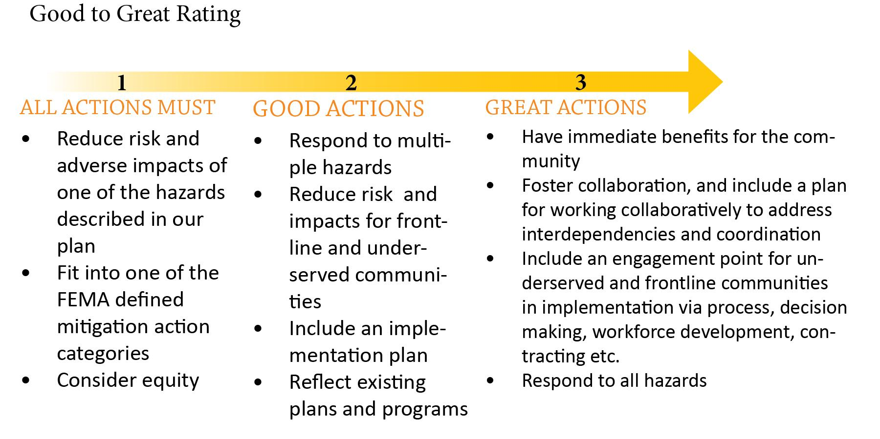
The Steering Committee then completed a cost benefit analysis of the projects in the plan. A full cost-benefit analysis is completed as part of any FEMA funded mitigation projects, so the Steering Committee conducted a planning-level assessment for each project. The Steering Committee compared the relative costs and benefits of each project by placing them into one of the four categories shown below. Further notes were made for each project to assist the evaluation process moving forward, these notes included the reporting contact and details about the type of project. Finally, the MAP Planning Team put the individual projects together into a cohesive strategy, described below.
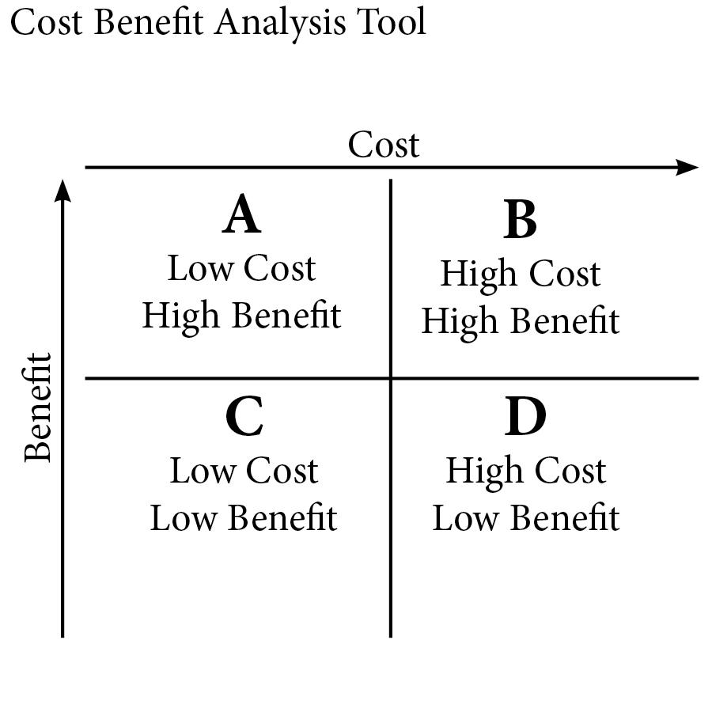

The Mitigation Action Strategy
**** This is where we insert the of the MAP Strategy (see spreadsheet)****

Related and Referenced Plans

The Mitigation Action Strategy represents just one type of resilience work being done in the City of Portland. It is a framework for the mitigation work that still needs to be done which is also, at times, recorded in other city plans and documents. The strategy builds on and refers to these other plans. The following is a list of related and referenced plans.

Resiliency Master Plan (BES)
The Resiliency Master Plan is the Bureau of Environmental Services’ plan for resilience related to earthquakes and climate change. It prioritizes improvements to wastewater and stormwater systems to reduce risk of infrastructure failure and increase the ability of services to withstand natural disasters. The Master Plan provides near-term actions and recommends long-term policies, investments, and programs which strengthen BES’s critical system components and infrastructure. The purpose of this document is to convey future programs and policies that will help the city meet seismic and climate change resilience standards by 2063. The Mitigation Action Plan refers to the BES Resiliency Master Plan as a critical part of the MAP strategy that falls within the Bureau of Environmental Services in their mission to manage Portland’s wastewater and stormwater infrastructure to protect public health and the environment.

Resiliency Strategy (PBOT)
The Portland Bureau of Transportation is currently developing a resiliency strategy for transportation infrastructure such as roads and bridges. In collaboration with the Regional Disaster Preparedness Organization, PBOT will also incorporate Regional Emergency Transportation Routes (RETRs) into the strategy as priority routes critical for rapid damage assessment, debris-clearance, and life-saving response actions. The document will also highlight modifications to these emergency routes and other improvements to physical and social infrastructure. The Mitigation Action Plan refers to the PBOT resilience strategy as a critical part of the MAP strategy focused on transportation projects that can reduce the negative impacts of natural hazards.

RIPE Report (City/ISS)
Published in June 2018, the RIPE Report identifies vulnerabilities within the City of Portland’s critical infrastructure systems and offers steps to building a multi-bureau disaster resilience and recovery framework. City staff from six bureaus as well as partners from PSU’s Institute for Sustainable Solutions used major earthquake and 500-year flood scenarios to identify critical infrastructure, assess interdependencies, and measure infrastructure recovery periods.
The RIPE report represents some significant learning related to disaster mitigation and recovery that has taken place since the 2016 MAP was completed. The report also stresses that major disasters can have cascading impacts on infrastructure systems, but by focusing on the intermediate and long-term recovery phases, rather than emergency response, the City may mitigate these effects. This involves building community support networks, creating permanent housing solutions, and implementing economic revitalization strategies. The 2021 MAP update includes projects recommended in the RIPE report including developing a collaborative governance strategy for resilience and recovery and piloting a resilient island concept based on community-based critical infrastructure.

Earthquake Response Plan (PBEM)
The Earthquake Response Plan (2012), developed by the Portland Bureau of Emergency Management, is a disaster framework that will guide Portland City government, regional partners, and private entities during a large magnitude earthquake. In conjunction with the City’s Basic Emergency Operations Plan (BEOP), it delineates critical response and recovery steps after a Cascadia Subduction zone earthquake. The Earthquake Response Plan notes that Portland’s infrastructure systems were constructed prior to understanding the Pacific Northwest’s seismic risk and describes susceptible transportation, water, sewer, and telecommunications assets. Due to these limitations, it is assumed that the City’s response capabilities will be overwhelmed and multiple bureaus will require additional resources and support from external/private entities. This plan focuses on response, but the risk analysis overlaps with the Mitigation Action Plan. The Earthquake Response Plan will be updated this year and will be informed by the Mitigation Action Plan update.

2020-2024 Portland Water Bureau Strategic Plan (PWB)
The PWB Strategic Plan is a five-year risk management plan that addresses climate-related challenges to Portland’s existing water system and regional emergency preparedness and resilience. In addition to highlighting areas of improvement, the Strategic Plan prioritizes building collaborative citywide partnerships and frequent reevaluation of strategic risks. The 2021 MAP points to the plan as a tool for emergency management and climate change mitigation strategies for protecting our water supply.

Water System Seismic Study (PWB)
The Water System Seismic Study, led by the Portland Water Bureau, includes seismic risk assessment of PWB’s water system and an infrastructure mitigation plan to achieve the Oregon Resilience Plan’s (ORP) water recovery goals. The seismic study was crucial for assessing pipeline and facility performance, modeling the city’s backbone water systems, producing emergency plans, and developing earthquake mitigation measures. The 2021 MAP refers to the implementation plan for this study and supports related mitigation projects, such as seismic retrofits, developing utility maps, and infrastructure evaluations, into future actions while simultaneously incorporating long-term resilience goals and objectives.

Water System Supply Master Plan (PWB)
The Water System Supply Master Plan (2020) is an update to the previous Infrastructure Master Plan and will ensure that Portland’s access to fresh, clean water is maintained for years to come. This Water Bureau-led effort considers future scenarios pertaining to climate change, ultimately guiding the city’s decision-making process for long-term water supply management. The SSMP will also identify improvement projects and possible changes to existing conservation programs. Several actions in the 2021 MAP update will support the SSMP.

Water Management and Conservation Plan (PWB)
The Portland Water Bureau developed a 2020 update to the Water Management and Conservation Plan. Their update accompanies the System Supply Master Plan as critical addition to respond to the expected impacts of climate change. PWB conducted water supply analyses to determine climate change impacts on Bull run storage and inform upcoming improvements to its water treatment processes. The WMCP’s 2025 conservation benchmarks will guide the selection of 2021 MAP actions in order to curtail Portland’s climate-related challenges.

Earthquake Ready Burnside Bridge Feasibility Study Report (Multnomah County)
The Burnside Bridge is a regional lifeline route across the Willamette River. Multnomah County’s Feasibility Study Report evaluates the Burnside Bridge during a Cascadia Subduction Zone earthquake and provides development alternatives such as maintenance, replacement, and enhanced retrofit crossing options. The study began in fall 2016 in which 100 Willamette River crossing options were analyzed through a multi-step screening process, resulting in four alternatives being recommended for evaluation. The 2021 MAP includes actions focused on bridge retrofitting and replacement and selection of alternative emergency transportations routes to support findings in the Feasibility Study.

Damage Assessment Plan (PBEM)
As part of PBEM’s Basic Emergency Operations Plan, the Damage Assessment Plan (2014) provides a collaborative framework that will help city bureaus assess damages to infrastructure, public property, and private property after a disaster. The goal is to create a citywide damage assessment process that will inform future disaster declarations, response and recovery actions, and acquire funding for short and long-term needs. It also aims to build an organizational structure that promotes cross-bureau and stakeholder participation. The Bureau of Development Services will head the plan’s update for city-owned buildings but it does not include other aspects of damage assessments such as bridges, water mains, waste and stormwater, and urban trees. The Damage Assessment Plan update is expected to be a 24 month long project and will be informed by the 2021 MAP.

Corporate Seismic Risk Assessment Study (Port of Portland)
The Corporate Seismic Risk Assessment Study (2015) outlines the seismic evaluation of valuable assets at, and adjacent to, the Port of Portland. These assets include airfields, buildings, utilities, piers, levees, and highway structures. The study looked at 18 key Port facilities to understand potential impacts of a Cascadia Subduction Zone earthquake and the economic impacts of taking on seismic resilience projects. The study also presents potential mitigation strategies with estimated implementation costs. Asset performance levels and mitigation measures identified in these assessments will guide the selection of implementation actions that pertain to seismic resilience in the 2021 MAP update. In addition, the Port of Portland is conducting a cost-benefit analysis that supports the development of a seismically resilient runway.

Regional Recovery Framework (RDPO)
The Regional Disaster Preparedness Organization developed a Regional Recovery Framework (2019) to coordinate city agencies and partners across the region in recovering from a natural hazard. Careful consideration is given to section 5, Recovery Support Functions (RSFs), which is an operational structure that provides resources and promotes coordination and collaboration between seven functional areas. The regional recovery framework can help us prioritize actions in the MAP strategy which are important regionally and provide a guide for collaboration and coordination with other jurisdictions.

Oregon Resilience Plan (OR Emergency Management)
The Oregon Resilience Plan (2013) is a policy guide for government agencies and includes recommendations that will protect communities, businesses, and infrastructure systems during and after a Cascadia earthquake and tsunami. The Oregon Seismic Safety Policy Advisory Committee (OSSPAC) led the development of the plan and formed eight task groups consisting of technical experts from government, university, and private sector as well as the general public. Each group determined the likely impacts of a magnitude 9.0 Cascadia earthquake and tsunami, set restoration timeframes for critical facilities, and recommended improvements to current practices and policies that will meet their 50 year resilience targets. The Oregon Resilience Plan considers long term resilience actions that are more drawn out than typical government planning efforts. Local plans such as the 2021 MAP update can refer to the Oregon Resilience Plan as policy guide for multi-generational planning and developing community-specific resilience measures in preparation for unpredictable natural disaster situations.

Disaster Debris Management Plan (PBEM)
As part of PBEM’s Basic Emergency Operations Plan, the Disaster Debris Management Plan (2014) supports a regional planning effort and aims to establish an organizational structure to coordinate debris removal and protect city operations in the event of a natural disaster. The plan also models debris volumes which helps determine the needs and capabilities of debris management. Disaster debris management was noted as an under planned and under resourced area in the 2016 MAP. An updated regional disaster debris plan is a critical part of the 2021 MAP strategy.

Climate Action Plan (BPS)
The Bureau of Planning and Sustainability published the 2015 Climate Action Plan to address climate change in the City of Portland and Multnomah County using innovative and equitable means. It describes climate change as an inevitable and serious threat to communities in Portland, particularly for low-income, non-white populations, and although Portland and Multnomah County lead the nation in carbon emission reductions, a more ambitious response is needed. As we begin to feel the impacts of climate change; climate mitigation and adaptation are becoming increasingly linked with disaster mitigation work. These areas of work also overlap in our focus on protecting frontline and underserved communities. The 2021 MAP builds on work that the Bureau of Planning and Sustainability has done to center frontline communities and identify important climate mitigation and adaptation strategies.

Community Wildfire Protection Plan (Multnomah County)
The Community Wildfire Protection Plan (2011) is a mitigation plan that identifies risks to citizens, the environment, and critical infrastructure and prioritizes strategies that make wildfire events less damaging in Multnomah County. The CWPP intends to increase wildfire awareness through community involvement and education, and integrate emergency operations and vegetation management projects to create more resilient communities. As of July 2021, Multnomah County is updating the CWPP which is expected to be completed in early 2022. This update comes at a time when recent smoke and fire events devastated surrounding communities, urging a re-evaluation of priorities and strengthening of collaborative partnerships. Because regional wildfires present a great threat to the Citythe MAP will point to the CWPP as the main source of wildfire protection strategies.

Floodplain Resilience Project
The Floodplain Resilience Project is a Bureau of Planning and Sustainability-led effort that aims to mitigate the effects of future flooding and floodplain degradation. Per FEMA guidelines, the project will also implement rules for new developments along water channels and increase protections for local wildlife. The Willamette River and other 100-year flood areas will be prioritized. Currently, the project is under development at the stakeholder outreach phase with City Council decisions to be made in Spring 2022.

Portland THIRA Update (RDPO)
The Portland Threat and Hazard Identification and Risk Assessment is a risk assessment process that helps identify potential risks and establish regional level goals, objectives, and priorities. The THIRA update is led by the Regional Disaster Preparedness Organization, a citywide resilience partnership, and is responsible for determining critical capabilities, assets, and resources in the Portland Metropolitan Region. The 2021 MAP can refer to the THIRA update as an important tool for disaster preparedness and resilience planning.

