Meeting Notes
Monday, March 8, 2021
3:00 Roll-Call / Introductions
Committee Members In Attendance:
David Breen, Port of Portland
Jenna Garmon, Metro
John Wasiutynski, Multnomah County
Stacey Foreman, City of Portland
Suzi Fulcher, Washington County
Tracy Fisher, Clean Air Construction Program Coordinator
Others In Attendance:
Bob Gaffney, Advanced Emissions
Jerimy Reis, Washington County
Eric Feeley, DEQ
Knowledge Murphey, Multnomah County

3:05 Public Testimony Period
No testimony provided.
3:15 Program Updates
- IGA amendment – Emailed to you for official signature
- Adding all agencies to website, review image. Tracy will make changes based on feedback and post to website.
3:30 CAC Agency Updates
City of Portland
- Finalizing software contract.
Metro
- Coordination with Construction Careers Pathways Program – similar timing for both programs, navigating new databases, discussed potentially providing joint trainings and coordination on outreach strategies.
- Attended Neighbors for Clean Air webinar on clean air legislation.
Multnomah County
- Working on training videos. Goal to produce first video this spring.
Port of Portland
- Preparation for FAA meeting. Updating specifications, saved onto Basecamp. Removed R99 requirement for now.
Washington County
- Met with capital project management group. Questions on fees and registering equipment for projects. Concern around registration fees.

3:45 Syncing Key Program Elements Discussion
- Registration Pricing: Identify programmatic goals for registration pricing
  - Brainstorm notes included below
  - Tracy to write up some registration fee decision points for next meeting.
  - Tracy will do outreach to invite contractors to comment on registration fee decision points for next meeting. Committee members can target contractors they would like to be present too.

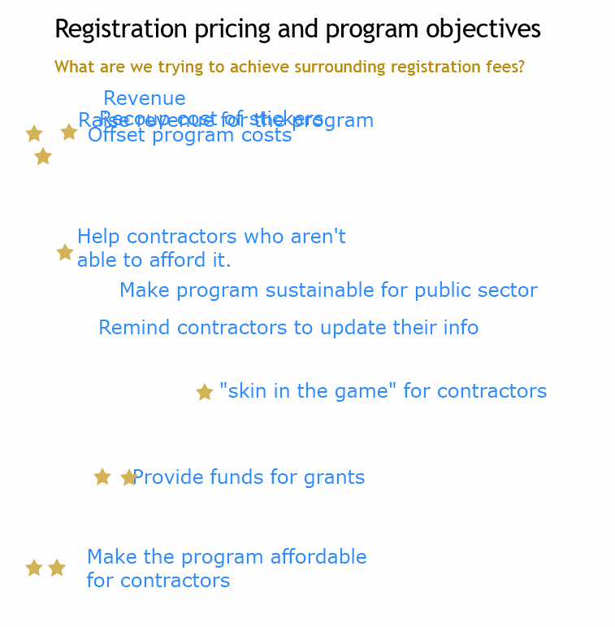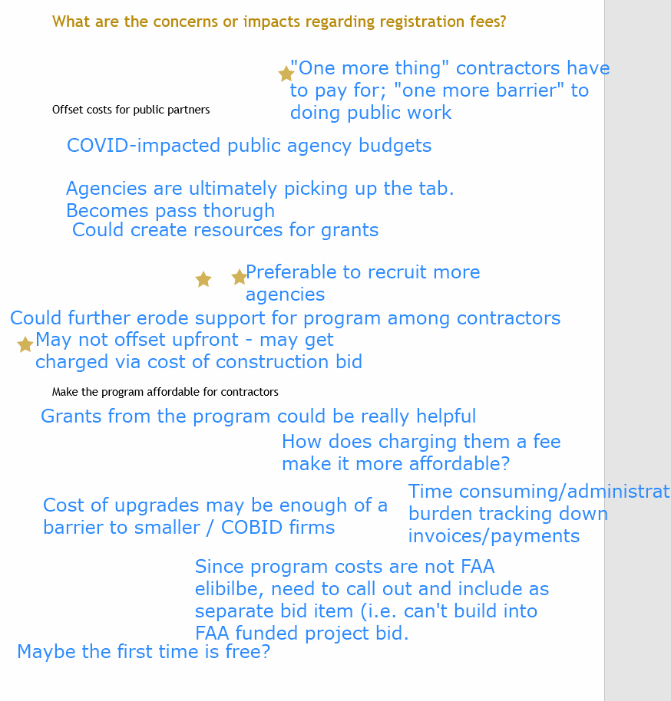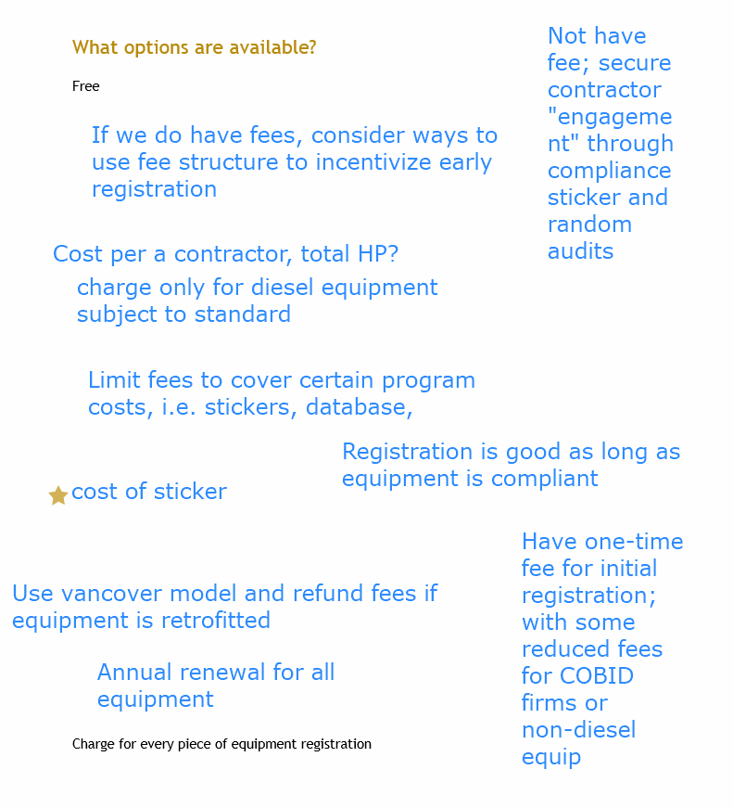

3:55 Final Comments & Notes for Future Meetings
Next meeting: consult contractors on registration fee decision points.

