New Portlanders Policy Commission, June 23rd, 2020
General Meeting Minutes

Commissioners present: Evelyn, Natalia, Rick, Octaviano, Maria, Salome, Baher, Djimet, June, Anne, Yonas, Kolini, Ahmed,
Commissioners absent:
Staff present: Andrea, Touk, Marco

- Welcoming and Check-in

The Chair highlighted and recognized the Commissioners ending their term or who have resigned, Evelyn expressed how much we appreciate their contributions, and that they are great people that have to leave now, we wish you all the best in their life, they are: Rick Birkel; Victoria Cross; Joe Enlet; Octaviano Merecias-Cuevas; Musse Olol; Sho Dozono; and Natalya Sobolevskaya

Evelyn also mentioned that we will have these members in the support list to reach out when needed. Some of the Commissioners shared a few words mentioning that they are available when needed.

Maria shared that she was resigning from the NPPC, commission because needs to take time for personal business.

- NPPC Recruitment of new commissioners

  - Review bylaws on membership
  - Recruitment process and timeline
  - Selection Committee

Review of NPPC Bylaws document related to recruitment process
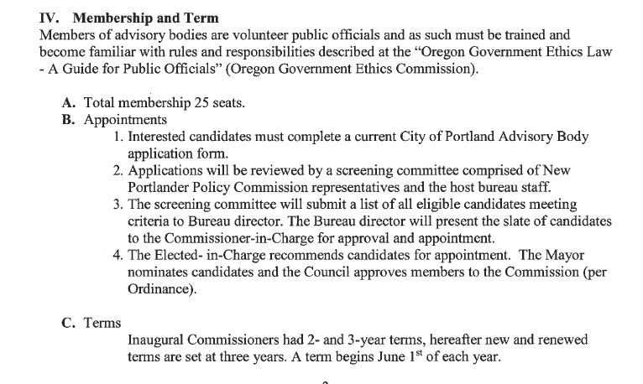

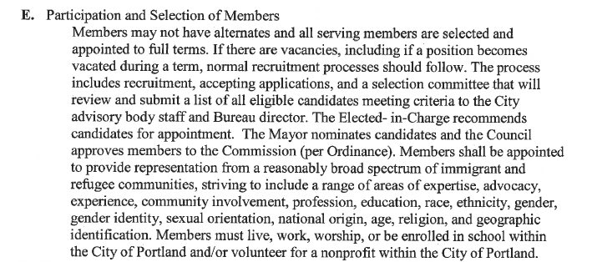

Seats open for recruitment:
- # of Members in period 2019-2020 = 23
- # of resignations = 2
- # of members ending their term = 5
- Total # of members the commission should have = 25
- Number of seats to be filled = 9 (and that we will recruiting for )

Recruitment process and timeline (See timeline diagram attached)

New Portlanders Policy Commission Recruitment Plan
June - November 2020

Criteria for new NPPC members recruitment:

- Should be connected, have ties to their communities, someone who knows their struggles, needs, culture, organizing, etc.
- Someone who wants to engage and take up on new things the NPPC experience offers.
- Not required but preferred if is tech savvy, strong speaking skills and strong conflict resolution background.
- People who have some history of community organizing, and activism in a broad social justice field
- Availability to be present at regular and sub-committee meetings as well as other NPPC public events.
- Able and willing to keep regular communications within NPPC needs through e-mail, text and phone media forms in a reasonable timely fashion.
- Been willing to learn about the NPPC mission and purpose and able to communicate what the NPPC is and do to people, community and public as needed.
- Been willing and able to follow regular requirements and commitments in meetings as well as when representing the NPPC.
- Strong leadership skills
- Show through their experience commitment to the NPPC mission and purpose and willing to support the work the NPPC does
- Uphold high Moral and ethical standards
- Willing to work with a diversity of people, in terms of age, ethnic background, sexual orientation, disability, culture, religious preference, etc.

Criteria for NPPC members recruitment from the City’s Advisory Bodies’ recommendations:
• You believe government is better when community is involved
• You are an advocate for racial equity: you want positive and long-lasting outcomes for racial and ethnic communities who have been left out before. You can bring discussion about racial and ethnic communities who need it the most.
• You have a perspective on physically navigating the community with a disability.
• You are available to attend all meetings and participate in the discussions

Selection committee
Criteria for selection Committee Member:
- New and longstanding NPPC members
- Be available to participate in the process which will take extra meetings and work for selecting new members from July through November (especially August and September during deliberation and selection)
- Experience on selection committees in the past if possible

Roles of selection committee members:
- Attend to orientation and planning meetings
- Review recruitment documents and
- Review applications and rate them accordingly with NPPC, bureau, city criteria’s
- Attend deliberation/selection meetings.
- Prepare final report of process and list of potential members selected to be approved by council

- NPPC Report to Council update

  - Marco will send after the meeting the link to participate in the virtual (video conference) session

The meeting is adjourned at 7:17pm

