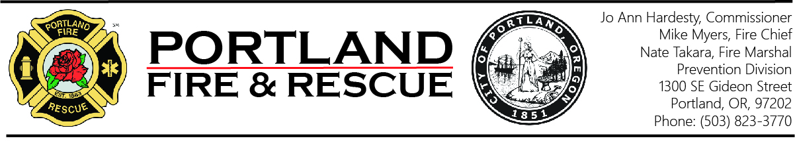

Smoke Alarm Test Report Form

Business Name:
Physical Address:
Mailing Address:
Owner / Agent:
Phone: |  |  |  |  | Email:

In accordance with FIR 6.10 - Abating Smoke Alarm Violations: The owner of a multi-family dwelling of three or more units, or their authorized agent, will ensure the testing of all smoke alarms are completed within each dwelling unit at a minimum of every six months. The authorized agent will document at least one of those tests on an annual basis. Written documentation of this testing shall be maintained and presented when requested by this office.

This form may be used as a record of the required smoke alarm testing. Enter the name of the individual or company conducting the smoke alarm test and have the owner/authorized agent sign and date the report verifying the information is correct. NOTE: Multiple units may be listed on one line.

Test Date | Testing Completed By | Unit(s) Tested

Owner/Agent Signature: |  | Date:

Test Date | Testing Completed By | Unit(s) Tested

Owner/Agent Signature: |  | Date:

