OUTREACH SUMMARY

Overview
The Portland Bureau of Transportation (PBOT) is currently working on Northwest in Motion, a project that will develop a 5-year implementation strategy for making walking, biking, and transit improvements in the Northwest District. PBOT hosted a NW Transportation Open House on November 15, 2018, providing an opportunity for participants to learn about several upcoming and future projects in the Northwest Portland. The Northwest in Motion portion of the event aimed to solicit feedback on the initial project list and how to prioritize the projects moving forward. Simultaneously, an online open house was made available to anyone who was unable to participate in the in-person event.
The goals of the in-person and online open houses were to:
- Inform stakeholders and community members about the project overall.
- Share the initial list of 20 projects with the community and see if it missed anything.
- Gather feedback about which projects PBOT should prioritize moving forward.
- Provide information about street classifications and proposed classification changes.
This document summarizes the key themes and trends from the outreach activities to help inform a refined list of initial priority projects.
Note: For a more detailed review of the public feedback, refer to the Appendix – All Comments Table, which include all individual results from survey questions, map comments, general comments, and demographics of participants.

Event Notification
The events were promoted in several ways, including:
Event Promotional Flier Distribution – PBOT staff and interns visited businesses and business-related networking events throughout the Northwest District to share information about the project and encourage participation in the online open house by staff and patrons.
Email invitations - An email was sent to project stakeholders to encourage participation in the online open house.
Social media – PBOT’s Facebook, Twitter, and NextDoor pages were used to generate interest in the project, and drive traffic to the website and the online open house.
Cross-event promotion – The open house was part of a broader NW Transportation Open House and was promoted to stakeholders of other PBOT and TriMet initiatives.

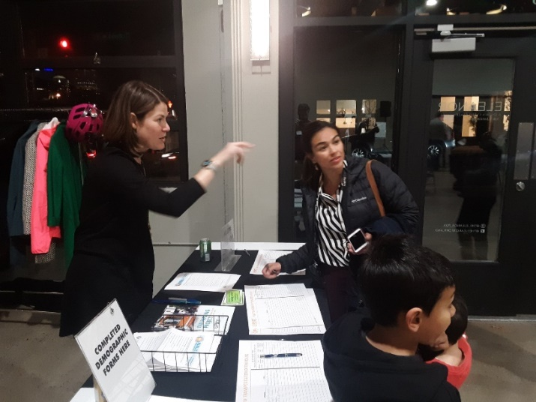
Overview of In-Person Open House
The in-person open house was part of the larger NW Transportation Open House, which included project teams, tables, and information from several different transportation projects happening across Northwest Portland. The Northwest in Motion section consisted of a series of display boards that highlighted the list of 20 proposed projects along with background information about the project, the process, and the timeline. Participants were provided with comment cards in order to select their preferred projects and provide additional comments about the project list or the project overall.
There was a total of 97 people at the open house. Of those, 17 filled out comment forms.

Overview of Online Open House
The online open house consisted of five stations:
- Overview: This station outlined the project purpose, goals and focus areas.
- Proposed Street Classifications: This station provided information about which streets would prioritize which travel modes and asked for feedback on proposed changes.
- Programmatic Improvements: This station provided an overview of improvements recommended throughout the project area.
- Potential Projects: This station provided information on the 20 proposed projects. Participants were asked to choose five that they thought were most important.
- Next Steps: This station provided information about the project timeline and ways to stay involved.
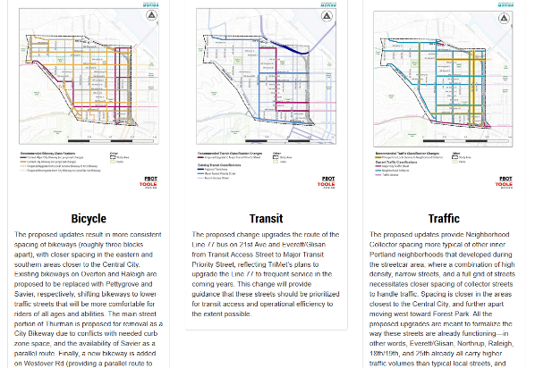
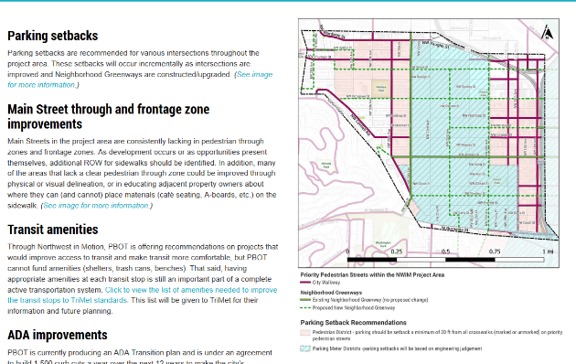
The online open house was open from November 15, 2018 to December 14, 2018. There was a total of 502 people that visited the online open house, while 57 of those people answered at least one of the questions.

Top Projects
Participants in both the online and in-person open house were asked to choose five projects from the list of 20 that best address the project criteria, listed as 1) improving safety, 2) improving connectivity, 3) meeting demand, and 4) improving equity. For each project, participants could also choose which of the four criteria the project addressed (from none to all). The projects were split into three categories: neighborhood greenway additions or improvements (10 projects), transit improvements (3 projects), and corridor safety improvements (7 projects).

Overall Projects
In terms of overall projects, all the 20 projects were chosen at least twice. The top three projects represented one from each of the three categories with Line 15 improvements, Pettygrove Greenway, and 23rd Avenue improvements chosen the most. Line 77 improvements and the 22nd Avenue Greenway round out the top five.
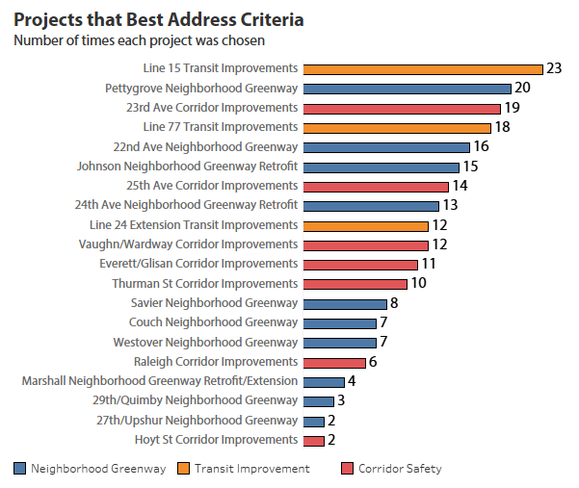

Connectivity
For the projects that were chosen because they improve connectivity, the project picked most was the Pettygrove Greenway, followed by Line 15 and Line 77 transit improvements. In general, transit improvements and greenways were considered better projects for improving connectivity with the Johnson Greenway Retrofit and the Line 24 extension improvements both ranking higher compared to the overall rankings.
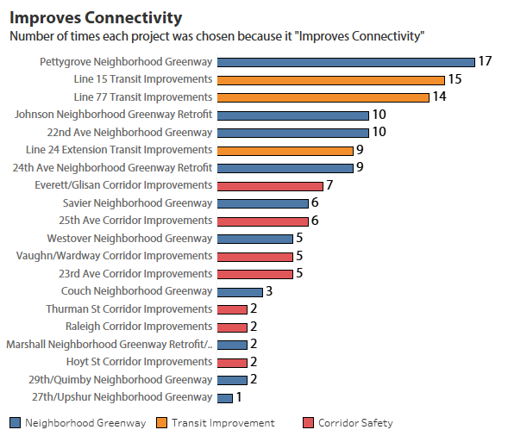

Safety
For the projects that were chosen because they improve safety, the Pettygrove Greenway was again chosen most frequently, followed by 23rd Avenue improvements and the 24th Avenue Greenway. The 24th Avenue Greenway Retrofit was ranked noticeably higher compared to the overall rankings.
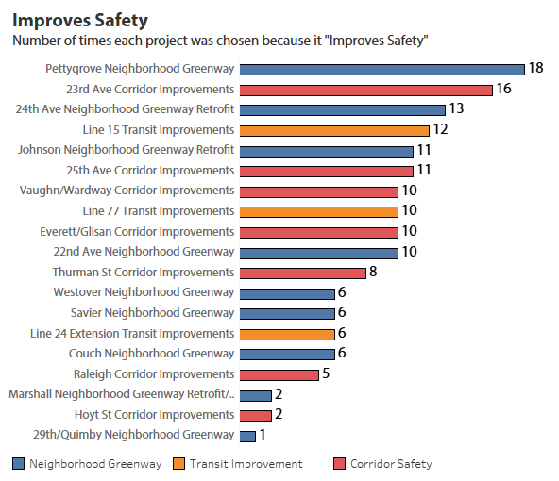

Equity
For the projects that were chosen because they improve equity, two transit projects – Line 77 and Line 15 improvements – were considered the best followed by the Pettygrove Neighborhood Greenway. The Line 24 Improvements ranked well for equity compared to the overall rankings.
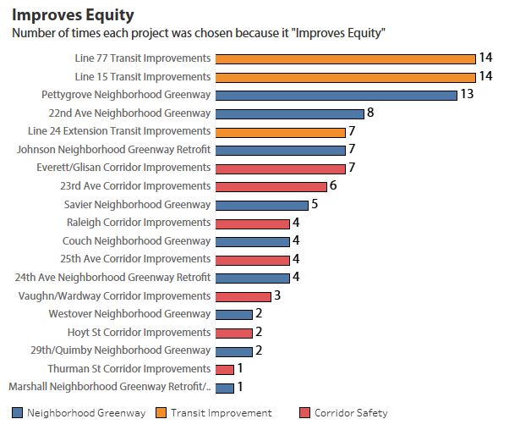

Demand
For the projects that were chosen because they best meet demand, transit improvements to Line 14 and Line 77 along with the Pettygrove Greenway were the top three. The 25th Avenue Corridor Improvements ranked well for demand compared to the overall results.

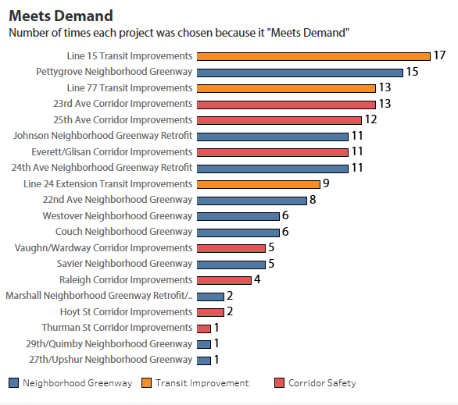

Street Classifications
Participants in the online and in-person open houses were provided maps and information about proposed street classifications. These included changing some streets to designated bikeways and transit priority streets, as well as reclassifying several local service streets to neighborhood collectors. Participants were able to provide comments about these street classifications.
A total of 34 people provided comments about the proposed street reclassifications. Key themes include:
- Worry about neighborhood collector changes – 7 comments. Seven participants mentioned that they did not want changes from local service to neighborhood collector streets.
- Pedestrian Safety issues – 6 comments. Six people pointed out that pedestrian safety improvements should be considered on any street reclassified as a neighborhood collector.
- Worry about changes to 25th as Neighborhood Collector – 5 comments. Five people specifically mentioned that they did not want 25th to be reclassified.
- Paving for Greenways – 2 comments. Two people mentioned that for any street reclassified as a bikeway, the city should prioritize repaving these streets.
- Do not increase congestion – 2 comments. Two people commented that they did not want to have any increases in vehicle congestion due to the changes.
- Do not make any changes – 2 comments. Two people requested that no changes be made to the street classifications at all.

See Appendix B for all comments.

General Comments
Participants in the online and in-person open houses were provided an opportunity to give general comments about the Northwest in Motion plan and the 20 proposed projects. Overall 43 people provided general comments. Key themes include:
- Unnecessary project – 6 comments. Six people commented that they did not think this was a good or necessary project at all.
- Good project – 5 comments. Five people voiced their support for the project overall.
- Focus on Burnside – 5 comments. Five people mentioned the importance of improving pedestrian and bicycle access along or across Burnside.
- Increased parking – 4 comments. Four people mentioned that parking was an issue. Two people specifically mentioned that adding markings for on-street parking would help increase the number of spaces.
- No turn on red – 2 comments. Two people voiced support for the idea of not allowing right turns on red lights.
- Safety on Thurman – 2 comments. Two people emphasized improving safety along Thurman.
- Safety on 25th – 2 comments. Two people emphasized the need for safety along 25th.

See Appendix C for all comments.

