Natural Hazard Mitigation Planning in Portland

Introduction
Portland’s ability to mitigate and prepare for natural hazards revolves around the city’s geography, climate, population, economy, and community priorities. All of which set the context for updating the Mitigation Action Plan (MAP). This chapter describes Portland’s communities and the resources available in developing this plan. Because this document is an update, some descriptions of geography and the community were drawn from the 2016 Mitigation Action Plan. In addition to describing Portland and its planning capabilities, this section relates the process we went through to update the MAP, details the planning Vision, Mission and Goals, and sets the foundation for the chapters that follow.

MAP Planning Area
The planning area for the Portland MAP is defined by Portland’s city limits. . The City of Portland is located primarily in Multnomah County in northwest Oregon, with small portions of the city extending into Washington and Clackamas counties (see Figure). The city covers 145 square miles centered on the Willamette River and its confluence with the Columbia River. Portland is the center of commerce, industry, transportation, finance and services for a metropolitan area of more than 2 million people. It is the largest city in Oregon, the seat of Multnomah County and the second largest city in the Pacific Northwest (after Seattle).
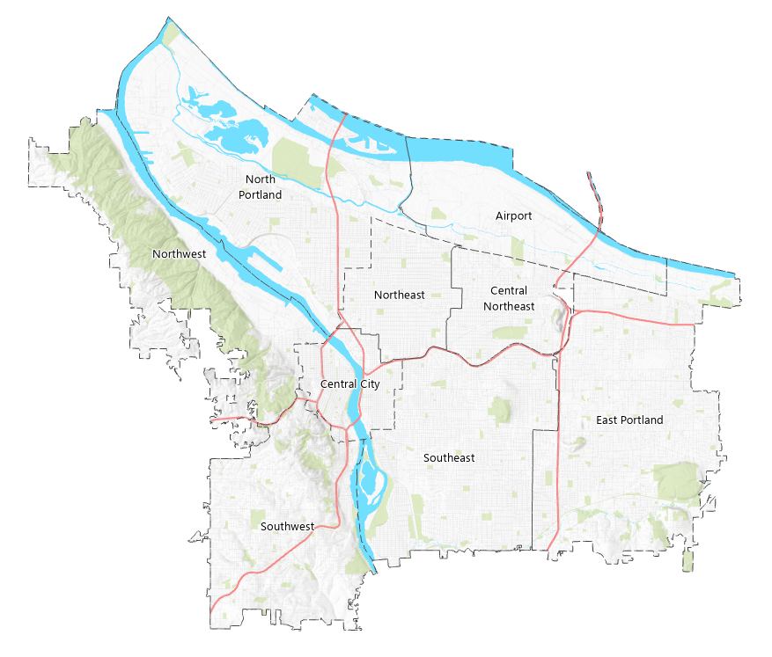
Figure 1. City of Portland

The Columbia River, which separates Oregon from Washington, is the city’s northern boundary. Major jurisdictions adjacent to the city are Beaverton, Tigard and unincorporated Washington County to the west, Lake Oswego, Milwaukie, Happy Valley and unincorporated Clackamas County to the south, and Gresham, Fairview and unincorporated Multnomah County to the east. The small city of Maywood Park is an island within the Portland city limits, in the northeastern part of the city.
Major transportation routes through the city are Interstates 5, 84, 205 and 405, U.S. Highways 26 and 30, the Willamette and Columbia Rivers, and several major railroad lines. Portland International Airport is along the Columbia at the northern edge of the city. There are 10 vehicle bridges across the Willamette River in Portland, and two across the Columbia River. Willamette River crossings also include a railroad-only bridge and a new bridge serving only mass transit, bicycles and pedestrians. An aerial tram provides transportation from the South Waterfront area to the Marquam Hill neighborhood.
The city park system includes almost 12,000 acres in developed parks, natural areas, and built acreage (Portland Parks & Recreation, 2016). This includes Forest Park, the largest urban forest in the United States, at over 5,000 acres (Forest Park Conservancy, 2016).

Geography and Natural Features
Portland lies at the northern end of the Willamette River valley, at the Willamette’s confluence with the Columbia River. The valley rises to the Coast Range of mountains on the west and to the Cascade Mountains on the east. The Willamette River begins in the Cascade Mountains almost 200 miles south of Portland. From Portland, the Columbia River Gorge flows northwest about 100 miles to the Pacific Ocean. Upstream to the east, the Columbia flows through the Columbia River Gorge, a break across the Cascade Mountains.
Elevations in the city range from about 20 feet above sea level along the Willamette River to over 1,000 feet in the Tualatin Mountains, which are more commonly called the West Hills (NHMP, 2010). The west side of the city is dominated by the West Hills, rising from a narrow terrace along the Willamette River. The east side is flat, with little elevation change except for a few volcanic buttes such as Mt. Tabor and Rocky Butte (Bureau of Environmental Services, 2006).
Soils on the west side of the Willamette River vary from clay loam with low permeability and relatively high erosion potential to gravelly loams, which are relatively well drained and moderately permeable. The flat areas along the west bank of the Willamette River are urban, with highly disturbed soil and unstable fill. On the east side of the Willamette River soils are highly variable, similar to the west side. Much of the area along the Columbia River has been filled with dredged sand, which drains very well. In undisturbed areas along the Columbia River, percolation (water flow through soil) rates are very slow. In the southeast areas of the city, soils vary from moderate to low permeability (NHMP, 2010).
Seismic and Volcanic Features
Most of the Pacific Northwest lies within the Cascadia Subduction Zone, where the Juan de Fuca and North American tectonic plates meet. The convergence of these plates puts most areas from western British Columbia to California at risk for a catastrophic earthquake with a potential magnitude of 9.0 or higher (Modified Mercalli Intensity Scale). Portland lies in this area of risk (NHMP, 2010).
Three major crustal fault lines run through Portland: the Portland fault, the East Bank fault and the Oatfield fault. Each is capable of generating moderately large (6.8) earthquakes (NHMP, 2010).
As a result of the subduction zone, there are active volcanoes nearby, including Mt. St. Helens, Mt. Hood, Mt. Adams and Mt. Jefferson. Major eruptions of these volcanoes could cause significant ash fall in the Portland area (NHMP, 2010).
Portland also lies atop the Boring Volcanic Field, a collection of cones and lava flows formed during one-time eruptive events. These include Mount Tabor, Rocky Butte and Powell Butte in east Portland. All existing Boring Volcanic centers are extinct, and the probability of an eruption in the Portland Metro area is very low (USGS, 2016a).
Surface Waters
The city of Portland lies within the watersheds of five primary surface waters, as described in the sections below.
Columbia Slough: The Columbia Slough Watershed drains an area of 51 square miles. The slough extends from Kelley Point Park on the west to Fairview Lake and Fairview Creek on the east. The watershed boundary includes portions of Portland, Troutdale, Fairview, Gresham, Maywood Park, Wood Village and unincorporated Multnomah County. Over the years, the watershed and waterway have been altered to accommodate industry and agriculture. Beginning in 1918, levees were built to provide flood protection. Wetlands and side channels were drained and filled to allow for development. Waterways were channelized, and dozens of streams were filled or diverted to underground pipes (BES, 2006).
Today, the Columbia Slough includes an 18-mile main channel and 30 miles of secondary waterways, many ponds and lakes, including the Smith and Bybee Lakes complex near the Slough’s confluence with the Willamette. The Upper and Middle Slough waterways are managed by the Multnomah County Drainage District. The watershed includes the Portland International Airport, the Portland Metropolitan Expo Center, Portland International Raceways, and a large industrial area; nearly 60,000 people work in the watershed. It is also the home to almost 160,000 people. Portland’s Columbia South Shore Well Field, which supplies supplemental drinking water to a large portion of the region, is also in the Columbia Slough Watershed (https://www.portlandoregon.gov/bes/article/147238#about Accessed 10/7/21).

Johnson Creek: Johnson Creek originates in Clackamas County and flows west for 25 miles to its confluence with the Willamette River. The watershed covers 54 square miles and includes portions of the cities of Milwaukie, Portland, Gresham, Happy Valley and Multnomah and Clackamas Counties. Crystal Springs Creek and Kelley Creek are Johnson Creek’s main tributaries and contribute the largest amount of flow to the main stem. Crystal Springs Creek is fed mostly by cold, clean groundwater from springs on the north side of Johnson Creek. Smaller tributary streams such as Mitchell, Errol, Deardorf, and Wahoo Creeks still flow, but about 38 percent of the watershed’s historical tributaries are now piped or diverted to the combined sewer system. The northern watershed is characterized by large, flat floodplains, particularly in Lents neighborhood. The topography south of the main stem, where most of Johnson Creek’s tributaries are located, is steep and varied. Approximately 175,000 people live in the Johnson Creek Watershed (https://www.oregonencyclopedia.org/articles/johnson_creek/#.YV8QFKBlCWZ Accessed 10/7/21)
One of the most significant changes in the watershed occurred in the 1930s when the Works Progress Administration attempted to control flooding by straightening, deepening and rock-lining the creek, creating a trapezoidal channel in 15 of the 25 stream miles. This work substantially altered the creek’s ability to dissipate energy and absorb high winter flows. Because of these alterations, steady rainfall and surging stormwater runoff from hard surfaces overwhelm the confined stream channel. As a result, Johnson Creek has flooded 44 times since 1940 (https://www.portlandoregon.gov/bes/article/318251 Accessed 10/7/21). The Johnson Creek floodplain has undergone substantial restoration in the last decade, The City of Portland Bureau of Environmental Services Watershed Management Program has taken on many flood management and restoration projects in the watershed through land acquisition programs and restoration plans.
Fanno Creek: Fanno Creek flows southwest for about 15 miles from its headwaters in Hillsdale to the Tualatin River near Durham. The Fanno Creek Watershed covers 32 square miles. About 4,529 acres are within the City of Portland. The remaining watershed area is mainly in Washington County. The Fanno Creek Watershed has steep slopes, steep stream gradients, and soils that are slow to infiltrate rain. These characteristics cause relatively high stormwater volumes and velocities, streambank instability and undercutting, erosion, instream sedimentation, and loss of streambank vegetation. More than 80 percent of the Fanno Creek Watershed in Portland is zoned for single-family residential use. The main stem Fanno Creek floodplain area has been cleared of vegetation and filled, reducing historical floodplain interactions and reducing habitat (https://www.portlandoregon.gov/bes/57717 Accessed 10/7/21).
Tryon Creek: The Tryon Creek Watershed in southwest Portland covers about 6 square miles, about 21 percent of it outside the Portland city limits in Multnomah County, Clackamas County, and the City of Lake Oswego. The watershed is divided into three sub-watersheds: Tryon Creek, Arnold Creek, and Falling Creek. Arnold Creek and Falling Creek are Tryon Creek’s main tributaries. Other smaller tributaries flow into Tryon Creek both within and outside Portland’s city limits. The main stem of Tryon Creek is about 7 miles long from its headwaters near Multnomah Village (just north of Interstate 5 and Highway 99) to its confluence with the Willamette River in Lake Oswego at the Highway 43 crossing (https://www.portlandoregon.gov/bes/57731 Accessed 10/7/21).
Significant residential development in the upper watershed above SW Boones Ferry Road has had negative effects on the condition of the watershed. Steep slopes and soils are slow to infiltrate water and increase surface runoff. These characteristics cause relatively high stormwater volumes and velocities, streambank instability and undercutting, erosion, instream sedimentation and loss of streambank vegetation. Residential development, impervious surfaces, and road crossings have severed the creek from its floodplain, decreased habitat and increased streamflow. Tryon Creek State Natural Area is in the lower watershed, and the riparian area along Tryon Creek is largely intact, providing habitat diversity (https://www.portlandoregon.gov/bes/57731 Accessed 10/7/21).
Willamette River: Portland’s Willamette River Watershed covers about 69 square miles. This makes it the largest watershed area in Portland, although it is still only about 0.5 percent of the river’s total drainage basin. Portland is the most highly urbanized portion of the Willamette River watershed. The City of Portland defines the watershed as the area of the city that doesn't drain into one of the other local watersheds This includes Forest Park, downtown’s commercial core, industrial districts on both sides of the river and Portland’s most densely populated residential neighborhoods. It is divided into three parts (1) The mainstem (2)Tributaries which includes many miles of tributary streams on the West Side including Stephens Creek, Balck Creek and Tanner Creek, and (3) East and Westside neighborhoods where most tributaries have been lost to development. (https://www.portlandoregon.gov/bes/71219 accessed 10/7/2021)
The watershed is highly urbanized. Its east side is almost completely developed, and the small streams that once crossed the area have been diverted into the sewer system. The steeper slopes in the West Hills are less densely developed, and most of the watershed’s remaining open stream channels are on the west side. Development, urban activities and structural changes throughout the watershed have diminished watershed functions and affected hydrology, physical habitat, water quality, and biological communities. Alterations to stream and riverbanks and channels has reduced floodplain functions and increased stream velocities (BES, 2006).
The volume of water upstream of Portland and the presence there of dams and reservoirs severely constrain the City of Portland’s ability to affect the hydrology of the Willamette River. Significant dredging, diking, and channeling of the main stem Willamette and its tributaries have altered habitat conditions. The main stem has been narrowed and deepened for flood control and navigation; off-channel habitat has been virtually eliminated, and the floodplain has been degraded. The river bank has been hardened with retaining walls and riprap, which prevents natural channel changes and minimizes the interaction between the river and riparian and floodplain vegetation (BES, 2006).

Climate
Portland is in the marine west coast climate zone. The Coast Range helps to shield the Portland area from Pacific Ocean storms. The Cascades offer a steep slope over which moisture-laden westerly winds rise, resulting in moderate rainfall for the region. Precipitation falls mostly as rain, which varies across the Portland metropolitan area. The West Hills receive 60 inches of rain per year, but the airport receives only about 36 inches. The city averages 155 days of measurable precipitation a year. It is not uncommon to see relatively dry summers in Portland. Nearly 90 percent of Portland’s annual rainfall occurs between mid-October and mid-May; only about 3 percent occurs in July and August (NOAA, 2019).
Winters can be mild to chilly and very moist, with January averaging 41.4 degrees Fahrenheit (°F). The Cascades generally block colder continental air masses from Canada, although cold air occasionally enters western Oregon through the Columbia River Gorge. Most temperatures during winter reach the 40s and lower 50s during the day and fall into the 30s at night. Temperatures below zero degrees are rare, occurring only six times since 1871. The city’s lowest temperature was –3 °F in February 1950. Snow accumulations are not frequent. Snow is most likely in areas above 500 feet or near the Columbia Gorge on Portland’s east edge. The average winter snowfall total is 4.3 inches (NOAA, 2019).
Despite average temperatures consistent with historical averages, three of the winters since 2016 saw winter storms that caused large transportation shutdowns and widespread power-outages. The winter storms of 2016-17 and 2020-21 were especially devastating. During a winter storm in January 2017, Portland was blanketed with 11 inches of snow in less than 12 hours, leaving more than 30,000 citizens without power in the region and shutting down businesses for a few days and up to a week (Dean & Loikith, 2017). More recently, in February 2021 the Tri-county region (Multnomah, Clackamas, and Washington counties) were buffeted by an ice storm that left more than 300,000 people without power, some for as long as two to three weeks (Williams, 2021). Thousands of power lines, trees, and houses were damaged during the ice-storm. While most of the severe damage occurred in Clackamas County southwest of Portland, the event demonstrates the continued risk of winter storms to the City of Portland.
Spring is a transitional season. March and April are often damp and cool, with only a few warm dry days. May and June become drier, with warming weather. Generally, afternoon temperatures warm from the 60s or 70s in May to the 70s or lower 80s in June (NOAA, 2019). Average temperatures in late spring have remained relatively stable since 2016, although hot weather seems to be coming sooner. In the six June months from 2016 to 2021, three years have seen temperatures above 100 °F and all have seen temperatures above 90 °F. In fact, June of 2021 saw the new highest recorded temperature in Portland’s history at 116 °F during a heatwave that lasted 5 days.
Three consecutive days of the June 2021 heat wave were record breaking temperatures at 108 °F, 112 °F, and 116 °F (NOAA, n.d.). The previous highest recorded temperature was 107 °F in August 1981 (NOAA, 2019). The June 2021 heat wave was responsible for between 50 and 90 deaths in Portland and Multnomah county, more than the total combined deaths to heat in the County for the past 20 years (Granillo, 2021). The average age of people who died was 71 years old, and the overwhelming majority did not have air conditioning, suggesting that wealth inequality was a determinant for death.
High pressure over the Pacific builds in the summer, with northwesterly winds prevailing in the afternoons and evenings. This high pressure prevents moisture from flowing into the area, so that summers often are dry and warm. August averages 69.5 °F. Afternoon highs in the 80s occur with regularity beginning in early July. Temperatures above 100 ºF are historically rare, usually occurring in July or August. In more recent years, June has consistently seen temperatures above 95 - 100 °F, and two of the last six July months have seen temperatures over 100 °F while three of the last six August months have seen temperatures over 100 °F. All summer months since 2016 have seen temperatures above 90 °F.
By early to mid- October, fall arrives with high temperatures back into the 60s. As nighttime hours increase, the valley cools more, allowing fog to form on clear nights. Fog can be dense during late night and early morning hours and can persist for several days (NOAA, 2019).
Destructive storms are rare in Portland. Surface winds seldom exceed gale force (50 mph or greater) and have rarely exceeded 75 mph. Wind speeds average 7.5 mph over the course of a year. Thunderstorms can occur during any month, but are not common. Thunderstorms in winter and spring are weak, producing small hail and brief gusty winds. Those in summer can produce lightning, strong winds and large hail. Occasionally, thunderstorms will produce funnel clouds, but tornadoes are rare (NOAA, 2019).
On average, the last occurrence of 32 ºF in the spring is March 30; the first of the fall occurs around November 8. First frost of fall is often around October 21, and the last frost of spring is typically near April 26. This makes for a long growing season (NOAA, 2019).
In summary, in the five years since the last MAP, the City of Portland has seen an increase in the extremes of heat and cold. Portland’s summer temperatures have been rising, with far more extreme heat events than is historically normal. Portland's winters have seen an increased quantity of winter snows and ice-storms, leaving thousands at risk of property damage and loss of electricity.

Demographics and Population Growth
The City of Portland is home to 654,394 people and has grown by almost 14% since 2010. While growth has slowed, the City has continued to see an increase in population every year. Population growth is a result of both seeing more births than deaths in the City and inward migration, with Portland netting 28,000 new migrants in 2020. It is expected that population growth may slow as a result of the COVID-19 pandemic and an accompanying economic decline, but this has yet to be forecasted. (Population Research Center Estimates).
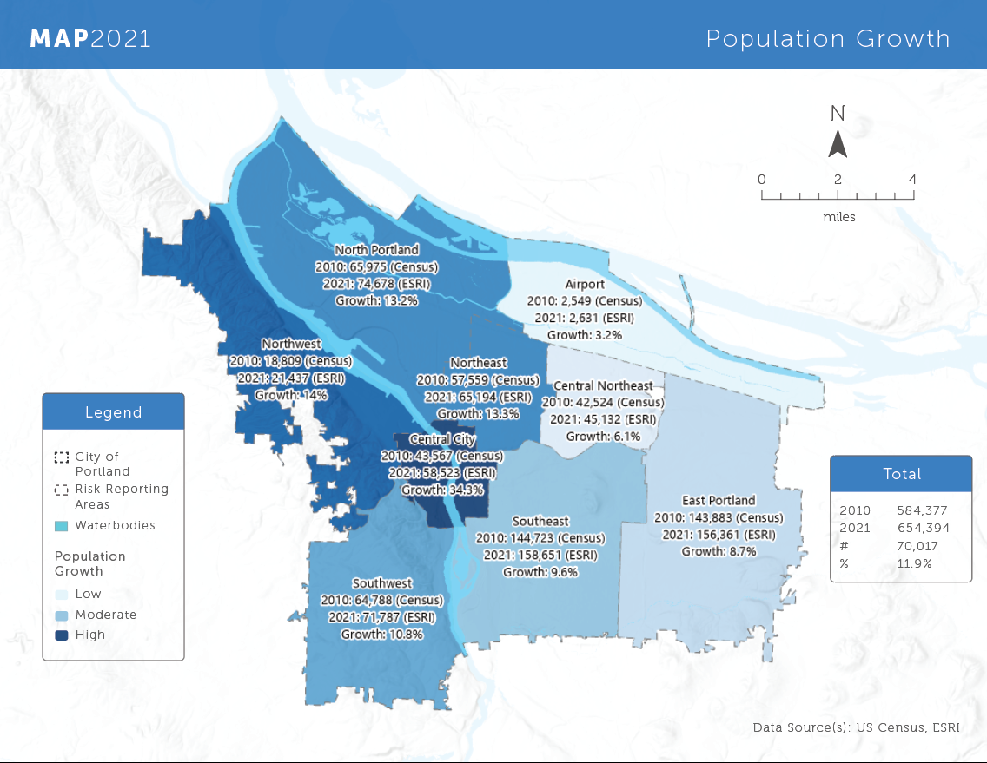

2010 | 2011 | 2012 | 2013 | 2014 | 2015
583,776 | 591,678 | 597,167 | 600,930 | 604,207 | 607,920

2016 | 2017 | 2018 | 2019 | 2020 | 2021
616,311 | 627,303 | 640,658 | 653,961 | 652,503 | 654,394

There are certain demographic groups we want to attend to more in natural hazard mitigation planning. These are underserved and frontline communities who will receive the first and worst impacts from disasters in our communities. They also often face the most barriers in receiving government support following a disaster (https://www.nytimes.com/2021/06/07/climate/FEMA-race-climate.html?action=click&module=RelatedLinks&pgtype=Article). In a FEMA National Advisory Council report to the administrator from 2020, they acknowledge the need to focus disaster preparedness, mitigation, response and recovery on these communities in order to “drastically improve” emergency management. They quote Dr. Kathleen Tierney who researchers the social roots of risk
“Disasters are often depicted as great levelers, victimizing rich and poor alike. The effects of disasters on populations are anything but random... The disaster vulnerability of individuals and groups is associated with a number of socioeconomic factors that include income, poverty, and social class; race, ethnicity, and culture; physical ability and disability; language competency; social networks and social capital; gender; household composition; homeownership; and age... The same factors that disadvantage members of society on a daily basis also play out during disasters (November 2020 FEMA National Advisory Council Report to the Administrator”.
The following is data related to these frontline and underserved communities in Portland.

These demographic groups and the risks they face from Natural Hazards are discussed further in the Risk Assessment chapter of this plan.

Development
The City of Portland has continued to grow since 2016. It remains committed to the vision of growing up not out, focusing on infill development within the Metro Urban Growth Boundary. This means that most growth within the City has and will continue to take place in existing neighborhoods. State land use laws require that the City dedicate land uses in accordance with predictions of future growth in the City.
The table below shows estimated current land use in the city derived from use descriptions provided in Multnomah County Assessor data.
Current Land Use in Planning Area

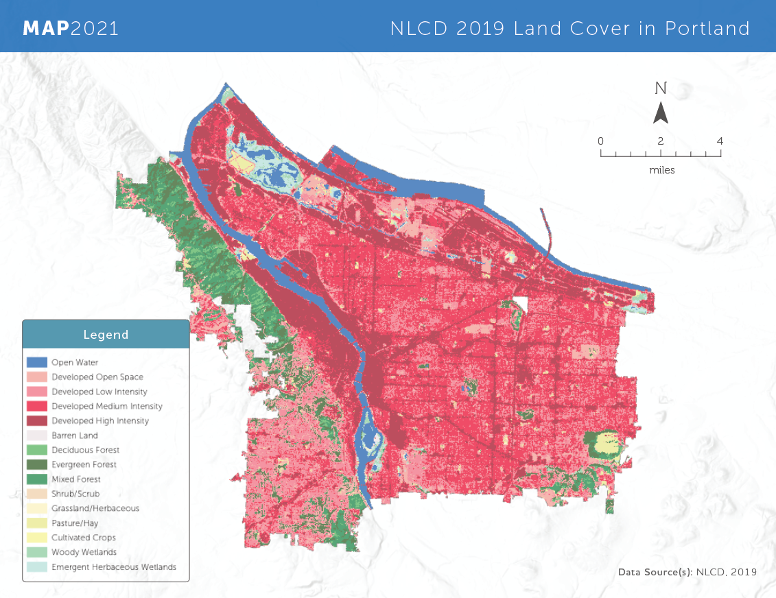
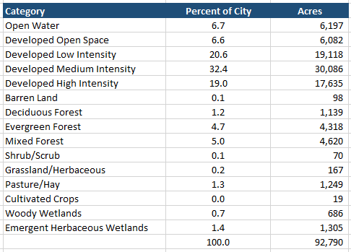

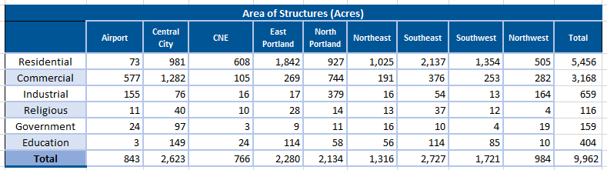
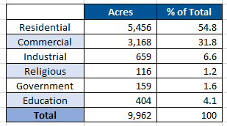

Building Count
The table below shows the type and distribution of structures throughout the planning area. This information is used in the risk assessment chapter for each hazard that has a defined spatial extent.
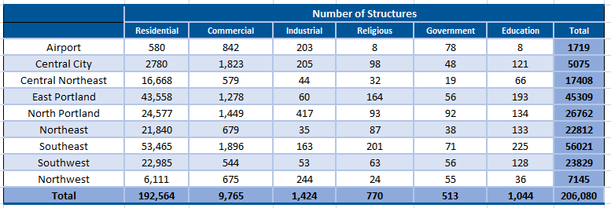

Critical Facilities
As part of the City’s resilience goals, the City has worked to identify critical buildings and infrastructure. The following map shows Critical infrastructure identified by the City’s infrastructure bureaus and buildings identified by the Portland Bureau of Emergency Management as critical in a disaster or response situation. Critical facilities are identified as such due to the role they play in ensuring the “continuity of security, safety, health, and sanitation services, support the area’s economy, and/or [maintaining] public confidence” or because, “Incapacitation or destruction of any of these systems or assets would have a debilitating impact on the area either directly, through interdependencies, and/or through cascading effects (CH2M Hill, 2007).”
The map below displays critical facilities and infrastructure in the following categories. (Due to the sensitivity of this information, a detailed list of facilities is not provided) :
- Public Health & Safety: Medical Facilities , Fire Stations, Police Stations, Emergency Operations Centers, Eldercare Facilities
- High Potential Loss: Schools, City Facilities, Military Facilities, Prison Facilities, Hazardous Materials, Nuclear Power Plants, Zoo
- Infrastructure, Wastewater, Potable Water, Oil, Natural Gas, Electrical, Communication, Dams
- Transportation, Airports, Bus Facilities, Rail Facilities, Light Rail Facilities, Highway Facilities, Port Facilities
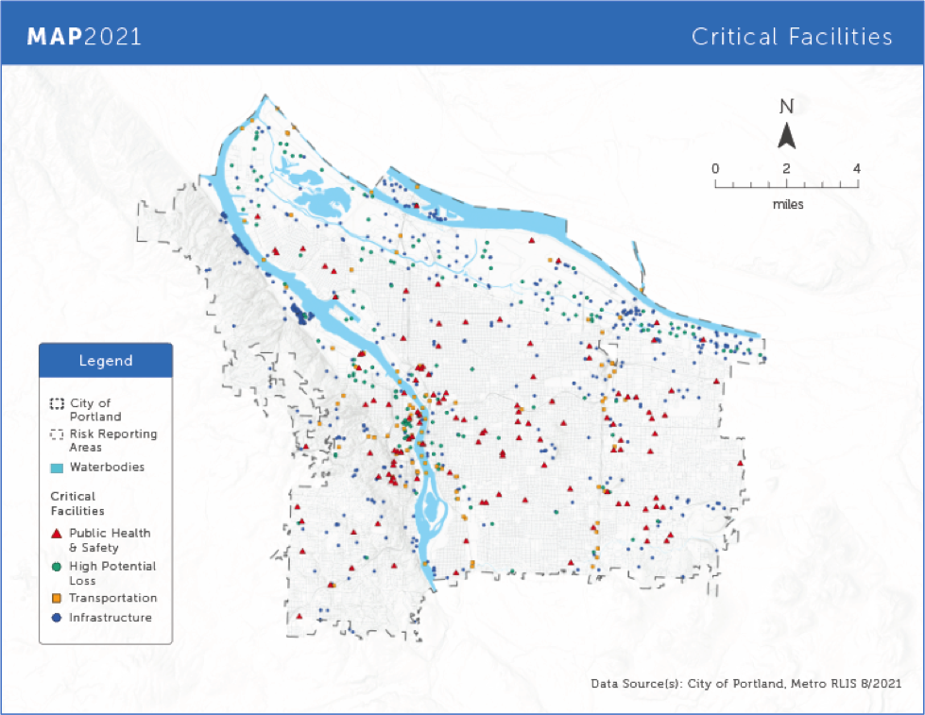
In addition to what is depicted on the map above, there are also 75 facilities outside of the city limits. These are facilities owned or operated by the Portland Water Bureau associated with the Bull Run Reservoir. They include three high potential loss facilities and 72 potable water facilities. All of the critical facilities and infrastructure identified here are discussed in the risk assessments for each hazard when relevant.

Economy

The City of Portland experienced 126 months of significant economic expansion prior to the Covid-19 pandemic. By 2018, the City had the third highest Median Household Income (MHI) growth in the U.S., rising from 26th to 13th overall, which is comparable to top cities such as Austin and Salt Lake City. In 2019, job growth increased by 2 percent and outpaced the national average of 1.6 percent. While corporate giants such as Nike and Intel cemented their economic influence in the region, Portland’s manufacturing sector also experienced significant growth and surpassed national statistics. This period of economic expansion increased domestic and global demand for products which generated a GDP worth $164.4 billion and added 2,587 manufacturing jobs in Portland. In total, 23,617 jobs were created in the City and 31,100 jobs were created in the Portland Metro by 2019 (PBA, 2020 & OED, 2019). Industries such as Transportation and Warehousing saw the most growth (11.3%) followed by construction (6.2%) and Information (3.6%). Leisure and Hospitality and Financial Activities rounded out the bottom two industries.
Despite increased prosperity and productivity, the City still experienced an unequal distribution of incomes that is less than the U.S. average, specifically in the higher income percentiles (PBA, 2020). Portland had the lowest share of total population employed at 48 percent (U.S. Census, 2018), and did not experience similar corporate tech or wage growth as to contending cities like Austin and Nashville. Although Portland raised its minimum wage by $1.50 to $11.25 in 2019, the cost of living grows more expensive and wages simply cannot keep pace with rising housing prices. The region’s growing population has put a strain on the housing stock as more long-time residents, oftentimes non-White populations, are displaced from their communities. From 2010 to 2018, communities of color have seen gradual economic traction but overall, they are still left behind in MHI, particularly Black and Hispanic/Latinx households (PBA, 2020).

2019 ACS 1 year Estimates for Portland Income Data (Table)
- MHI - 76,231
- Per Capita Income - 45,035
- Income of $100,000 or more - 38.2%
- Income below $50,000 - 32.5%
- Families 2018-2019 below poverty level - 6%
- Residents 2018-2019 below poverty level - 12.3%

Current Context and Future Outlook
The environmental, demographic, developmental and economic factors that make up Portland align closely with the 2016 MAP and changes in Portland correspond with what was predicted five years ago, but some unique circumstances provide additional context for this plan and present some uncertainties about the future outlook. This includes the COVID-19 pandemic, a housing and homelessness emergency, a racial justice movement and social unrest.
COVID-19 Pandemic: The 2021 MAP update was completed during the COVID-19 pandemic. The City of Portland is responsible for the continued administration of services and the stewarding of Portland’s economy as well as the wellbeing of its many communities. Thankfully, the direct health of the City’s residents have been less affected by COVID-19 compared to other regions, but the citywide shutdowns and social distancing guidelines, which are estimated to have saved 2000 lives, had major repercussions on the economy of Portland (Portland Business Alliance [PBA], 2021). In February 2021, the PBA released a “State of the Economy” report which evaluates Portland’s economy on an annual basis. The report describes how the “COVID-19 pandemic shut down our economy and a massive recession followed” (PBA, 2021, n.p.). In the first days of April 2020, as the pandemic was beginning, Portland and the State of Oregon saw a 40% decrease in consumer spending and nearly a 15% spike in unemployment, centered in the retail and food services industry—although no sectors were spared (PBA, 2021). More recent data from the State of Oregon Employment Department in August 2021, has Portland and the Metro region at 4.9% unemployment, up from around 3% before the pandemic. Consumer spending has largely recovered, although decreased spending in restaurants, hotels, recreation, and entertainment persist.
The economic outcomes of the COVID-19 pandemic disproportionately affect women, people of color, and low income individuals. Oregon’s unemployment rate is as much as two percent higher for women than men (PBA, 2021). This gender disparity in the workforce does not reflect national estimates and may suggest a harder road to recovery for women in Oregon. As of February 2021, the national unemployment rate was 6.1% for women and 7% for men (Kochhar & Bennett, 2021). Unemployment rates also intersect with race or ethnicity, with national unemployment rates showing markedly higher increases in unemployment rates for Black and Hispanic men and women compared to their White counterparts (Kochhar & Bennett, 2021). Based on national samples, Asian, Black, and Hispanic or Latino households reported “difficulty paying usual monthly expenses,” at 10%-15% higher rates than White households (PBA, 2021). And atop these disparities, national samples show that job loss caused by the pandemic was as much as four times worse for low wage employees compared to middle wage employees, and that high wage employees saw almost no increase in unemployment by the end of 2021 (PBA, 2021).
Housing and homelessness emergency: Updating Portland’s MAP took place during an ongoing housing and homelessness emergency which has been exacerbated by the COVID-19 pandemic. This context is an important factor when we consider the potential impacts of natural hazards on people. The City of Portland has an ongoing state of emergency on housing and homelessness which began in 2015 (Vespa, 2019), and which has been extended through April 2022 (Ellis, 2021). During the pandemic, Portland has seen a surge of long-term homeless encampments which drives the public perception of an increase in the homeless population (Vespa, 2021). The 2019 Point in Time Count showed a decrease in homeless individuals from 4,177 in 2017 down to 4,015 in 2019. The same count reported an increase in unsheltered homeless individuals from 1,668 in 2017 up to 2,037 in 2019 (City of Portland, 2019a). Portland’s Point in Time Count is done biannually, but due to health and safety risks relating to the pandemic, the City has delayed the 2021 count to January of 2022 (Vespa, 2021). This delay means that data on the potential increase in homeless individuals due to the COVID-19 pandemic is unavailable. Dr. Marisa Zapata, the Director of Portland State University’s Homelessness Research & Action Collaborative said in an interview with KOIN6 news that the ongoing eviction moratorium was likely limiting increases in the homeless population (Arden, 2021).
While it is unclear if the houseless population in Portland has increased quantitatively, there has undoubtedly been an increase in encampments, and the City has a looming eviction crisis. At the start of the pandemic, Portland’s City Council adopted ordinances to reduce or limit the eviction of homeless encampments throughout the city due to health and safety risks. Over the course of the pandemic, the decision to halt evictions of homeless encampments supported the health of city employees and may have helped alleviate some hardships for homeless people in the City. However, with the reduced evictions, housing encampments became more prevalent and visible within the City (Hayden, 2021a). Portland’s City Council is actively assessing and updating guidelines to reduce the prevalence of homeless encampments, especially around schools and public property (Hayden, 2021b).
As mentioned above, federal and state eviction moratoriums have protected renters in Portland from eviction due to financial hardship stemming from the pandemic. From April 2020, through July, 2021 renters were able to defer rent payments to February 28, 2022, and a host of other eviction limitations were in effect along this timetable (see “Oregon Eviction Moratorium FAQ,” Portland Housing Bureau, n.d.). With the end of the eviction moratoriums and the upcoming deadline for delayed rent payment, researchers expect the City of Portland and the State of Oregon will see a surge in evictions (Bates et al., 2021). Portland State University’s Homelessness Research & Action Collaborative estimates that as many as 125,000 households in Oregon are at risk of eviction, with potential costs for the State estimated to range from $720 million to $4.7 billion (Bates et al., 2021). It is unclear how many of these at-risk households are located in Portland. If the distribution of these at-risk households matches the population distribution in the State, then as many as 18,750 households may be at risk of eviction in the City of Portland alone. Bates et al. (2021) recommend quick and decisive action to curb the potential fallout mass evictions would cause.
Racial Equity: Readers can find comprehensive information on the status and history of residents of color in Multnomah County and the City of Portland in a series of six reports from the Coalition of Communities of Color and Portland State University, each subtitled An Unsettling Profile (Curry-Stevens, Cross-Hemmer, & Coalition of Communities of Color, 2010). For the sake of this MAP update we summarize disparities in the aggregate for people of color and do not explore multiple races or ethnicities, as those reports do. It is fair to say that strong and even extreme disparities persist between residents of color and their White counterparts in Multnomah County.
The State of Oregon, Multnomah County, and the City of Portland’s histories are awash in colonialist and racist policies and practices. For example, a report from the City of Portland (2019b) writes,
Portland, like many U.S. cities, has a longstanding history of racist housing and land use practices that created and reinforced racial segregation and inequities. Exclusionary zoning, racially restrictive covenants, and redlining are examples of this, with their effects still visible today. These discriminatory practices have all played a role in shaping the city’s urban form—and in exacerbating inequities along lines of race and class (p. 4).
Throughout Portland’s history a select few neighborhoods have been deemed by policy to be of greater importance than other areas of the City. The neighborhoods of most importance were overwhelmingly White and affluent, while the least important neighborhoods contained most of the City’s population of people of color. In the 1980s and 1990s, after decades of divestment from neighborhoods deemed of least importance, the City of Portland faced problems of abandonment and exceedingly high poverty rates in many of its urban neighborhoods (Gibson, 2007). Subsequent efforts to reinvest in so-called “blighted” communities resulted in large-scale gentrification and displacement, as it was White families who were most able to buy and invest as property values increased (Gibson, 2007).
Estimates indicate that more than 26% of Multnomah County’s population are people of color. These people and communities face disproportionate rates of poverty, unemployment, educational disparities, healthcare disparities, higher rates of juvenile detention and adult imprisonment, etc.
As of 2008, communities of color in Portland face poverty rates double those of Whites and child poverty rates over 20% higher than White children (Curry-Stevens et al., 2010). More recent census data shows an overall decrease in poverty rates in Multnomah county from an average of 18.5% of people in poverty from 2010-2014 down to an average of 13.8% of people in poverty from 2015-2019 (Portland State Population Research Center, 2020). However, statewide data suggests that despite an overall decrease in poverty rates, similar degrees of inequity persist for both adults and children. Around 13% of White adults in Oregon are in poverty compared to 27% of Black adults, 19% of Hispanic or Latino adults, and 24% of Native American adults. On the other hand, 13% of White children in Oregon are in poverty compared to 34% of Black children, 29% for Hispanic or Latino children, and 27% for Native American Children. Economic inequalities compound with educational inequities that begin in access to preschool programs and persist into highschool. Seven percent of White students do not graduate high school while 30% of students of color do not graduate high school. For a more complete list of disparities, and historical and contemporary factors contributing to them, see Communities of Color in Multnomah County: An Unsettling Profile. The authors of that report argue that the disparities experienced by citizens of Multnomah county are significantly worse than the national averages, and are significantly worse than the comparable King County, home to Seattle.
As it pertains to this MAP update, Portland is home to a sizable population of people of color, and due to historical discrimination and contemporary inequities, these populations are at higher risk of harm to natural hazards. Systematically disadvantaged communities face greater challenges in accessing resources in times of crisis, and a lack of wealth in these communities and families makes for a harder road to recovery following a disaster. Furthermore, decades of racist and discriminatory policies undermines trust between these communities and city officials. It is imperative that resilience work in the City of Portland fosters relationships with communities of color to develop trust and support those communities at highest risk of harm.
Civil Unrest: Beginning in the final days of May 2020, with the killing of George Floyd in Minneapolis, the City of Portland saw a wave of civil unrest with large marches and demonstrations occurring daily for four months through the end of September 2020. Smaller marches and demonstrations continued through the winter and persist in the Fall of 2021. The Summer of 2020 was a conflagration of strife for the continued racial inequity in the City and Nation alongside anxieties pertaining to the COVID-19 pandemic and large scale job loss. The elongated and often destructive nature of the civil unrest has impacted the economy and public perception of Portland.
Most demonstrators in the Summer of 2020 were peaceful marchers. Many heartfelt moments inspired empathy and a coming together of the residents, as when marchers laid across Portland’s Burnside bridge for nine minutes to symbolize the nine minutes George Floyd was restrained. As thousands of citizens called for systemic change in the City, new social movement networks developed and a few policy changes occured at the city including a reallocation of funds from the Police Bureau to the Portland Street Response team (Dooris, 2020).
Some protestors had less peaceful intentions, and a culture of violent opposition persisted throughout the protests. The Portland Police Bureau (2020) reported a total of 30 riots within the city from May through November, half of which occurred in the month of August. Over this time period, hundreds of instances of vandalism were reported, dozens of fires were started, hundreds of illegal fireworks and mortars were set off, and hundreds of projectiles were thrown at police officers. In total, the Portland Police Bureau arrested 960 people in association with the riots and illegal activities. The City of Portland and the Portland Police Bureau have been critiqued by protestors for excessive use of force and other illegal activities during the protests. The Multnomah County District Attorney’s Office has opened 21 cases for review about alleged police use of excessive force, one of which has resulted in an indictment at this time (Wilson & Levinson, 2021).
The long-term costs of the civil unrest remain unknown, but the damage to public opinion pertaining to the City of Portland at the national and local levels will certainly incur an economic toll. At the local level, the City of Portland has already allocated more than a million dollars to assisting businesses make repairs and clean up graffiti (Goodwin, 2021). Regardless, residents of Portland reported in a survey to the Oregonian newspaper that they felt the downtown area was “unsafe,” “trashed,” or “destroyed,” and that many of the respondents now avoided visiting Downtown Portland (Goldberg, 2021a). Without revitalized consumer counts, many businesses in Downtown Portland will continue to struggle financially. National indicators are similarly gloomy for Portland. In a survey of tourists in the United States in 2021, for the first time, more people considered Portland an unappealing destination than considered it appealing, and since the beginning of 2020, the amount of tourists who considered Portland an appealing destination dropped from 54% down to 32% (Goldberg, 2021b). These surveys paint a challenging picture for the upcoming path to recovery in the City of Portland, especially for the Downtown area and the Hotel and Hospitality sectors of the economy.
Summary: As the above contexts show, the 2021 Portland MAP update is taking place during a time of unprecedented challenges for the City of Portland. Compared to peer regions, the City of Portland is seeing a higher unemployment rate, more dramatic decreases in apartment construction rates, and a sharp drop in real estate market ranking (PBA, 2021). The Portland Metro, and the Central City in particular, have seen significant drops in apartment rents compared to surrounding cities and smaller neighborhoods (PBA, 2021). These indicators suggest that the City of Portland is seeing a decrease in apartment-dwelling residents and a decreased number of people moving to the city compared to pre-pandemic levels. At the same time, many of the standard and economic, development and growth indicators used to describe the City in this plan appear stable; it’s uncertain how this context will impact the City in the next five years. In the coming years, mitigation planning and all resilience work will need to address recovery from these crises.

Planning Capabilities and Strengths
The City of Portland operates under a commission form of government that was established in 1913. An elected mayor and four commissioners make up the City Council and have both legislative and administrative duties. City Council approves budgets, establishes laws and regulations, and oversees City bureaus and departments. The Mitigation Action Plan is adopted by the City Council as a coordinating document that brings together the work of many of the City’s Bureaus. The City of Portland has extensive resources for completing this type of planning. A list of City resources that add to Portland’s capabilities in completing the MAP is in the appendix. This list was developed as part of the 2016 MAP and updated for this plan.
The Portland Bureau of Emergency Management leads the planning, programs, and policies to continually advance the city's mitigation, preparedness, response, and recovery capabilities. Their work supports ongoing programs that facilitate planning for the MAP and further the work described in the Mitigation Action Strategy chapter of this plan. This includes community engagement related to disaster resilience and emergency response, supporting continuity of operations planning (COOP) for the City of Portland and local businesses and community organizations, and working with regional partners and across City bureaus to support the collaborations necessary for hazard mitigation work.
Collaboration is an essential component to natural hazard mitigation. City Bureaus that deal with infrastructure (e.g., water, transportation, environmental services), planning and development (e.g., Planning and Sustainability, and Development Services), emergency response (Emergency Management, Police and Fire), and social services (Community and Civic Life) are all engaged in their own resilience work on a regular basis. Due to Portland’s form of government and the specialized nature of each bureau, there are groups that foster cross-bureau collaboration to work on issues related to disaster resilience. The following list is a few of the most notable collaborative groups:
Disaster Policy Council: The Disaster Policy Council is a cross-bureau leadership group that promotes inter bureau cooperation to further the City’s emergency management goals. The group advises the mayor on policy matters during an emergency, approves plans related to emergency management, and monitors ongoing work and plan. https://www.portland.gov/code/3/125

Regional Disaster Preparedness Organization: The City of Portland participates in this regional partnership of government, non governmental organizations, and private-sector stakeholders to increase disaster resilience.

Climate Change Preparation Team: The City of Portland Climate Preparation Implementation Team is a group of staff from several City bureaus who collaborate on climate preparation, adaptation and resilience. The group was founded around the City’s 2015 Climate Change Preparation Strategy, and has continued to meet regularly during the year to share lessons learned and identify cross-bureau actions for citywide climate resilience.

The Disaster Resilience and Recovery Action Group (DRRAG): provides a forum for cross-bureau collaboration around building resilient infrastructure and coordinating resilience and recovery planning among infrastructure bureaus.

The City Asset Managers Group (CAMG) includes representatives from infrastructure, development permitting, financial, and planning bureaus. They meet regularly to share best practices, policy, and approaches to maintain city assets.

The Emergency Management Steering Committee (EMSC) is established by City Code to advise PBEM on programs and plans. It includes emergency management representatives of all the public safety and infrastructure bureaus, plus some other critical functions like IT and HR. The group meets monthly, and representatives from outside agencies like the County, hospitals, and the Port of Portland often attend.

The groups mentioned above are actively engaged with work related to hazard mitigation in Portland. These groups and the City bureaus they bring together are engaged in ongoing work to build resilience and have created plans, programs and policies to mitigate risk from natural hazards. Many of these plans are mentioned in more detail as part of the Mitigation Action Strategy chapter of this plan.

Plan Update Approach
The official kick-off to the Mitigation Action Plan update began in January of 2021. The City of Portland selected the Institute for Sustainable Solutions to lead and collaborate with the Portland Bureau of Emergency Management on the planning process. With the 2016 MAP expiring in November of 2021, the planning process took place on an expedited time frame, which required a unique and dillenget approach to completing the MAP update. During this time, COVID-19 still loomed large—the City and most key stakeholders were working remotely and dealing, in real time, with response and recovery efforts related to the pandemic, regional wildfires, and other contextual challenges described elsewhere in this plan.

The planning process was organized according to four teams that lead different pieces of the update.
The planning team: To start the project, we assembled a Planning Team to serve as the center of gravity. The planning team managed the project, brought together research and deliverables produced by the other teams, conducted public outreach and outreach to stakeholders outside the City, and drafted the plan. The Planning Team consisted of Jonna Papefthimiou from the Portland Bureau of Emergency Management, Beth Gilden from the Institute for Sustainable Solutions, and Rica Perez from the Institute for Sustainable Solutions. This team had been working together over the last several years to further disaster resilience in the City of Portland, and this experience served as the foundation for collaborating on the 2021 MAP update.

The Steering Committee: The Steering Committee brought together stakeholders from the City of Portland and neighboring jurisdictions whose work aligns with the Mitigation Action Plan. Participants included emergency managers, asset managers, planners, and policy makers. The role of the Steering Committee was to make key decisions related to the plan update. They established geographies for analysis; set the Vision, Mission, and Goals; and developed the Mitigation Action Plan Strategy. The Steering Committee met regularly during the planning process to review work done by other teams; provide updated resources, data, and information; and acted as ambassadors of the plan to the people they work with by sharing plan updates and soliciting feedback.

The Risk Assessment Team: The Risk Assessment Team focused on the hazard analysis and vulnerability assessment. They updated the 2016 hazard profiles to reflect new data/research, changes in the development of the built environment, and to add in new experiences from recent natural hazards. In addition to these updates, the Risk Assessment Team also improved on the 2016 plan by better describing risks to frontline populations, integrating climate change into their description of the hazards, and improving the readability of the hazard descriptions and accompanying maps.

The Community Engagement Team: The Community Engagement Team identified community needs and priorities that should be reflected in the plan. They focused on frontline and underserved communities who may be left out of typical public involvement activities yet who would be most impacted by many of the natural hazards described in this plan.

A description of each team, and the focus of their work is in the figure below. Once each team had been established, work plans were developed to coordinate across teams (work plans are included in the appendix). Each team started their work in January or February and came together regularly at Steering Committee meetings to make key decisions.
Team | Area of Responsibility | Team Members and Represented Organizations | Stakeholder Engagement
Planning Team: | Create the work plan for the planning process, project management, guide the process, track and bring together work of other teams and committees, to guide the process and undertake project management tasks, provide public information via the website, emails and interfacing with questions from the public, coordinate with other | Jonna Papaefthimiou. Planning Manager and Interim Executive Director of Portland Bureau of Emergency Management  Beth Gilden, Collaborative Projects Manager, Institute for Sustainable Solutions  Rica Perez, Graduate Research Assistant Institute for Sustainable Solutions | Public outreach  Neighboring jurisdictions and regional partners  Agencies and individuals involved with mitigation planning  Key external stakeholders including those involved with the 2016 MAP
Steering Committee | The Steering Committee brought together stakeholders from the City of Portland and neighboring jurisdictions whose work aligns closely with the Mitigation Action Plan. The role of the Steering Committee was to make key decisions related to the plan update and develop the Mitigation Action Plan Strategy. The Steering Committee also met regularly throughout the planning process to review work being done by other teams, provide updated resources, data and information related to the update, and acted as an ambassador of the plan for the people they work with—sharing plan updates and soliciting feedback when necessary. | Portland Bureau of Emergency Management Aaron Fox  Bureau of Environmental Services Nishant P  Bureau of Environmental Services Kate Carone  Portland Parks and Recreation Chris Silkie  Portland Parks and Recreation Laura Lehman  Bureau of Planning and Sustainability Sallie Edmonds  Bureau of Planning and Sustainability Mindy Brooks  Office of Equity and Human Rights Nickole Cheron  Portland Fire Steve Bregman  Portland Police Edina Na Songkhla  Portland Water Bureau Kim Anderson  Portland Bureau of Transportation Emily Tritsch  Portland Bureau of Transportation Courtney Duke  Bureau of Development Services Ericka Koss  Bureau of Development Services Anne Castelton  Portland Fire Kim Kosmas  Portland Fire Nate Takara  Portland Fire Louisa Jones  Clackamas County Jay Wilson  Multnomah County David Lentzner | Colleagues in mitigation work  City leadership  Technical experts who could provide updated information and data related to the plan
Risk Assessment Team | The Risk Assessment Team was responsible for updating the risk assessments—incorporating new data, changes in development and identifying | Dr. Peter Dusicka, Professor of Civil and Environmental Engineering at Portland State University  Dr. Yu Xiao, Associate Professor in the Toulan School of Urban Studies and Planning at Portland State University  Zachary Boyce, Student Intern | Technical experts
Community Engagement Team |  | Dr. Amy Lubitow, Professor Sociology at Portland State University  Rica Perez, Graduate Research Assistant Institute for Sustainable Solutions | City staff and community leaders working with frontline and underserved communities  Direct outreach to community in Portland Parks

Reviewing the 2016 Plan
The first task for the Planning Team was to review the 2016 plan with the Steering Committee and other key stakeholders. The Steering Committee and key technical stakeholders were asked to provide new research and data that should be incorporated in the update. Some of the new research that the reviewers thought should be included in the plan were:
- The Fifth Oregon Climate Assessment (Oregon Climate Change Research Institute)
- Earthquake regional impact analysis for Clackamas, Multnomah and Washington Counties (DOGAMI)
They also suggested contacts for obtaining updated growth and land use information. The new reports and data were incorporated into the relevant sections of the plan--in particular the Risk Assessment. Reviewers also provided feedback on the overall plan, how it could be improved and what major changes they would like to see. They suggested that the update should be more readable, that the plan go further to center equity and community, and that the plan should increase focus on more frequent but less severe hazards like heat and ice storms.

During this review period, the Planning Team collected notes and status reports on all projects listed in the 2016 Mitigation Action Strategy and developed a summary report. Some of the key findings from the Mitigation Action Strategy evaluation included:
- Stakeholder opposition, lack of political will, or low staff capacity and resources caused projects to stall or be discontinued.
- Implementation actions were grouped by lead agency which led to multiple cross-bureau projects with unstandardized language and heavy overlap. A disaggregated list of actions hindered inter-bureau collaboration and communication.
- The Mitigation Action Strategy contained passive language such as encourage, support, and advocate this made it difficult to assess progress for many actions.
- Community engagement projects and programs progressed incrementally. There is an opportunity to reassess the Strategy’s equity perspective which may help determine culturally appropriate actions and foster trust with frontline and underserved communities.
The suggested changes described above influenced the 2021 MAP Update and can be seen throughout the rest of this plan. A summary of changes by chapter is also included in the appendix.

Engaging Stakeholders and Public Involvement
Each MAP update team was responsible for engaging with different types of stakeholders. The Planning Team took on outreach to neighboring communities, local, and regional agencies involved in hazard mitigation; regulators; special interest groups; and community-based organizations. Due to COVID-19 all engagements were done virtually. Since many of these stakeholders were engaged in response and recovery work related to the pandemic and other crisis, the engagement strategy emphasized bringing planning questions and updates to existing meetings. The Planning Team also met individually with stakeholders who represented important parts of the community or held specific technical information.

The 2021 Plan Update benefitted from many concurrent planning efforts. The Multnomah County Natural Hazard Mitigation Plan update provided a forum for the Planning Team to collaborate and coordinate with the County, where the majority of Portland sits. A Metro-led effort to develop a “Social Vulnerability Tool” for the region allowed the Planning Team to connect with organizations and technical experts who were assessing social risks from Natural Hazards. And finally, a regular meeting organized by the Regional Disaster Preparedness Organization of a “Mitigation and Recovery Committee” allowed the Planning Team to connect with regional partners engaged in resilience work throughout the planning process. A full list of the stakeholders the Planning Team engaged with is located in the appendix.

The Planning Team also took on some of the basic functions of public outreach. The Team created an “opt-in” email list for plan updates. They sent out a survey to 500 community members who had participated in or shown interest in the 2016 MAP. They posted meeting notes, plan updates, and draft plan sections for comment on the plan website:https://www.portland.gov/pbem/map-2021, and (more information will be added here at the end of the public outreach process. Supporting documents that detail these outreach activities are included in the appendix.

Targeted outreach was done by the Risk Assessment and Community Engagement Teams. The Risk Assessment Team worked with technical experts to provide information and feedback for their analysis. A full list of the technical experts who consulted on the risk assessment is included in the appendix along with the data sources used for the risk assessments. The Community Engagement Team focused on engaging frontline and underserved communities who may have been missed by other public outreach. A complete description of their work is included in the “community voice” chapter and their activities are detailed in the appendix.

Key Decisions
The Steering Committee was responsible for making the key decisions for the plan. This involved setting the Vision, Mission, and Goals of the plan; the geography used for analysis; the hazards to be considered and prioritized; and the development of the Mitigation Action Strategy.

Establishing the Vision, Mission, and Goals: Early in the planning process, the Steering Committee established the Vision, Mission, and Goals for the 2021 MAP update. The Vision, Mission, and Goals combined what was established in the 2016 MAP with more recent resilience work. The Vision, Mission, and Goals were revisited at the start of every Steering Committee meeting to ensure they still reflected the priorities and information learned through the planning process.
Vision: “Portland is a prosperous, healthy, equitable and resilient city where everyone has access to opportunity and is engaged in shaping decisions that affect their lives” (City of Portland 2035 Comprehensive Plan).
Mission: To equitably reduce risk and the adverse impacts of natural hazards by building community resilience through collaborative, cost-effective actions and strategies.

Goals
- Protect life and reduce injuries.
- Engage and build capacity for the whole community.
- Minimize public and private property damage.
- Protect, restore, and sustain natural systems.
- Minimize the disruption of essential infrastructure and services.
- Integrate mitigation strategies into existing plans and programs.
- Prioritize multi-objective actions that can further sustainability and equity goals during “ordinary times”
- Build on collaborations and lessons learned from resilience work that has occurred since 2016
- Incorporate community voice and reflect the priorities of frontline and underserved communities

Defining the Geography: The Steering Committee was also tasked with defining the geography of the MAP. This included establishing not only the planning area—which is the area within Portland’s political boundary, but to also identify other geographical units to be used in the MAP. In 2016, City Budget areas were used to present local-level information about development, people, hazards, risks and mitigation projects. The Steering Committee felt that using these smaller geographies was a helpful tool for communication, but wanted to ensure that the geographies would also be useful for analysis. For the plan update,the City-budget area boundaries were moved slightly to reflect updated census geographies. A map of these smaller scale geographies is below.

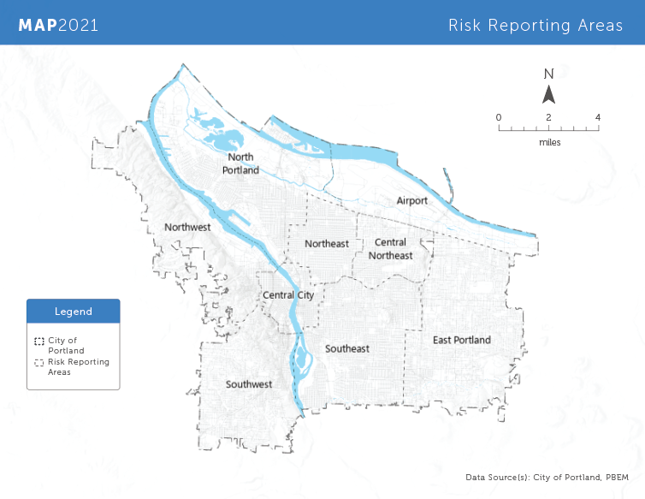

Prioritizing the Natural Hazards to Include: The Steering Committee identified and prioritized the Natural Hazards to include in the plan. They drew from the lists of hazards in the 2016 MAP, reviewed the Oregon Natural Hazard Mitigation Plan, and considered personal experiences with recent natural hazards in Portland. The Steering Committee selected the following list of hazards and assigned a level of analysis they felt corresponded with each hazard.
Earthquake—Deep Analysis
Flooding and Dam Failure—Deep Analysis to meet CRS requirements
Wildfires and Smoke—Medium Analysis, working with Multnomah County and RDPO
Landslides—Medium Analysis, working closely with BDS
Extreme Heat—Medium Analysis, focusing on PSU and RDPO resources
Winterstorms (Snow, Ice, Cold)—Medium Analysis (focusing on historical and climate change impacts)
Drought—Light analysis
Volcanoes—Light analysis
Windstorms—Light analysis
Some of the weather-related hazards were disaggregated from their format in the 2016 MAP for the plan update. The impact of smoke was added to assessment of wildfires, and extreme heat was prioritized after the City experienced multiple heat waves. The Steering Committee revisited this list throughout the planning process as the Risk Assessment Team presented them with results from their analysis. Midway through the planning process, the Steering Committee was asked to rank which hazards were of most concern. The hazards were ranked according to the average score assigned by Steering Committee members. Earthquake was selected as the most concerning hazard by more than half of the Steering Committee, while others selected Flood, Wildfire and Smoke, and Extreme Heat as the hazard they were most concerned about. Windstorms and Volcanoes were overwhelmingly ranked hazards of least concern.

Earthquake
Flood
Wildfire and Smoke
Extreme Heat
Winter Weather
Landslide
Drought
Windstorms
Volcano

Steering Committee members selected earthquakes as the most concerning due to the potential scale of impacts the Cascadia Earthquake could cause, while flood, wildfire and smoke, and extreme heat were ranked highly due to the frequency of occurrence and impacts on marginalized communities. These rankings are reflected in the level of analysis completed for each hazard and their reasons for concern are addressed in the risk assessment chapter.

