Example of a remit envelope that also functions as an Attestation Form for Open & Accountable Elections program purposes.

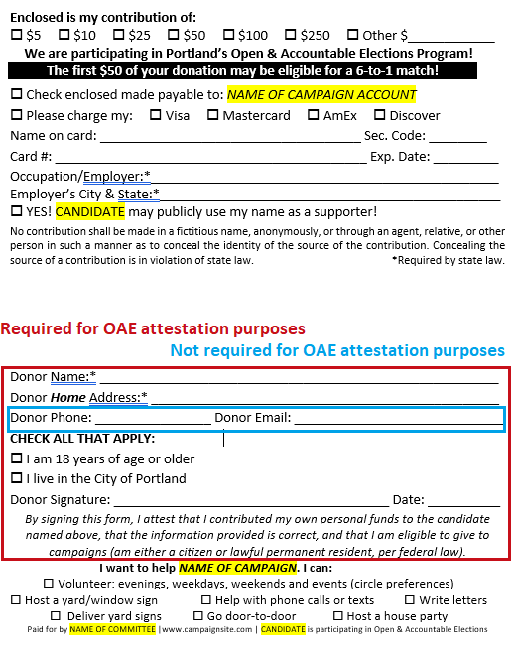

See next page for a compliant remit you can copy and paste, customize it for your campaign, and have it printed onto envelopes.

Enclosed is my contribution of:
$5 $10 $25 $50 $100 $250 Other $____________
We are participating in Portland’s Open & Accountable Elections Program!
The first $50 of your donation may be eligible for a 6-to-1 match!

Check enclosed made payable to: NAME OF CAMPAIGN ACCOUNT
Please charge my: Visa Mastercard AmEx Discover
Name on card: ____________________________________ Sec. Code: ________
Card #: ___________________________________________ Exp. Date: _________
Occupation/Employer:*________________________________________________
Employer’s City & State:*_______________________________________________
YES! CANDIDATE may publicly use my name as a supporter!
No contribution shall be made in a fictitious name, anonymously, or through an agent, relative, or other person in such a manner as to conceal the identity of the source of the contribution. Concealing the source of a contribution is in violation of state law. *Required by state law.

Donor Name:* _______________________________________________________
Donor Home Address:* ________________________________________________
Donor Phone: ________________ Donor Email: _____________________________
CHECK ALL THAT APPLY:
I am 18 years of age or older
I live in the City of Portland
Donor Signature: ______________________________________ Date: __________
By signing this form, I attest that I contributed my own personal funds to the candidate named above, that the information provided is correct, and that I am eligible to give to campaigns (am either a citizen or lawful permanent resident, per federal law).
I want to help NAME OF CAMPAIGN. I can:
Volunteer: evenings, weekdays, weekends and events (circle preferences)
Host a yard/window sign Help with phone calls or texts Write letters
Deliver yard signs Go door-to-door Host a house party
Paid for by NAME OF COMMITTEE |www.campaignsite.com | CANDIDATE is participating in Open & Accountable Elections

