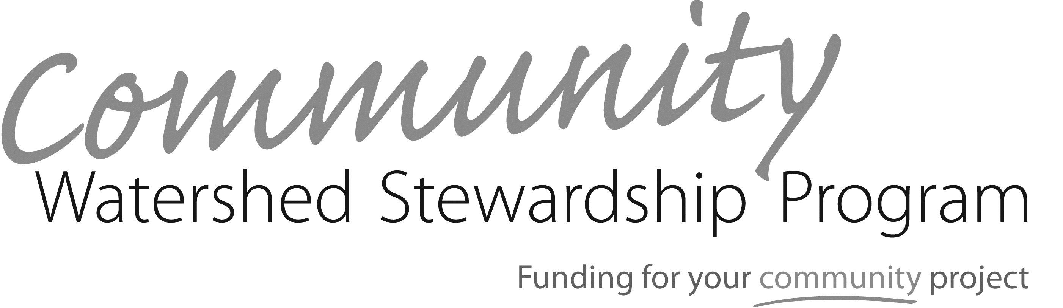
2024-2025 Pre-Application Form
Potential applicants must submit a pre-application describing the proposed project and how it meets the eligibility requirements. Please use the Grant Guide as a reference throughout the application process. For further assistance, please contact the CWSP Coordinator at CommunityStewardship@portlandoregon.gov. Pre-application forms are due January 22, 2024.
PROJECT COORDINATOR
NAME: |  | Title:
Phone: |  | EMAIL:
ORGANIZATION
organization: |  | WEBSITE:
address: |  | pHONE:
ORGANIZATION
PROJECT DESCRIPTION
PROJECT NAME: |  |  |  | eSTIMATED cwsp GRANT rEQUEST: ($12,000 maximum)
prOJECT lOCATION—aDDRESS OR CLOSEST STREET AND CROSS STREET
WATERSHED:  Please check the watershed(s) in which the project is located:  ☐ Fanno Creek  ☐ Tryon Creek  ☐ Johnson Creek  ☐ Willamette RIver  ☐ Columbia River  ☐ Unsure |  | CATEGORY:  Under which program categories does your program fit?  (Select all that apply)  ☐ Pavement Removal and Urban Restoration  ☐ Clean-up Projects  ☐ Natural Area Restoration  ☐ Environmental Education and Art  ☐ Rain Gardens and Stormwater Management  ☐ Youth Leadership  ☐ Community Garden
 |  | ☐ Other:
PROJECT SUPPORT
Please identify the fiscal agent and property owner and confirm their support.
FISCAL AGENT:
PROPERTY OWNER:
PROJECT SUPPORT
Provide a one-paragraph summary that describes your project.
SELECTION CRITERIA
Please explain how your project contributes to each of the following criteria. See Grant Guide.
Note: Final funding decisions are based on all three criteria.
WATERSHED BENEFITS:
cOMMUNITY pARTNERSHIPS:
eQUITY:
Submit application by mail:  COMMUNITY WATERSHED STEWARDSHIP PROGRAM  City of Portland  Bureau of Environmental Services  ATTN: CWSP Coordinator  1120 SW 5th Ave, Suite 613  Portland, OR 97204 | Submit application by email: CommunityStewardship@  portlandoregon.gov
Upon receiving Pre-Applications, the CWSP coordinator will notify applicants
that their submissions are being assessed.
WS 2031 NOV 2023

