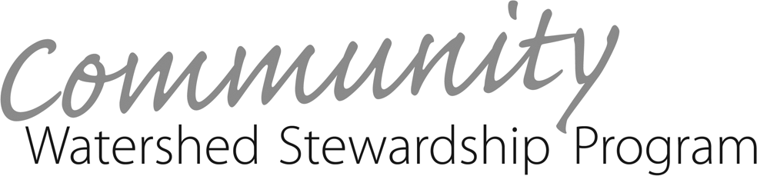

2024-2025 Full Application Form
PLEASE READ THE GRANT APPLICATION GUIDE before completing this Application Form. This Application Form must be completed in full and submitted with all required supporting documentation. See Grant Application Guide for more details.
If you require further assistance, please contact the CWSP Coordinator at
CommunityStewardship@portlandoregon.gov

Application deadline is March 11, 2024. | For Administrative Use Only:
A. Applicant Information
Section I: Project Coordinator
Project Coordinator Name:
Organization:
Mailing Address:
Phone Number: | E-mail:
Section II: Fiscal Agent (if different from project coordinator)
Fiscal Agent Contact Person:
Fiscal Agent Organization:
Mailing Address:
Phone: | E-mail:

- I have thoroughly read through the full application and the grant application guide, including the insurance requirements.

Sign: Date:

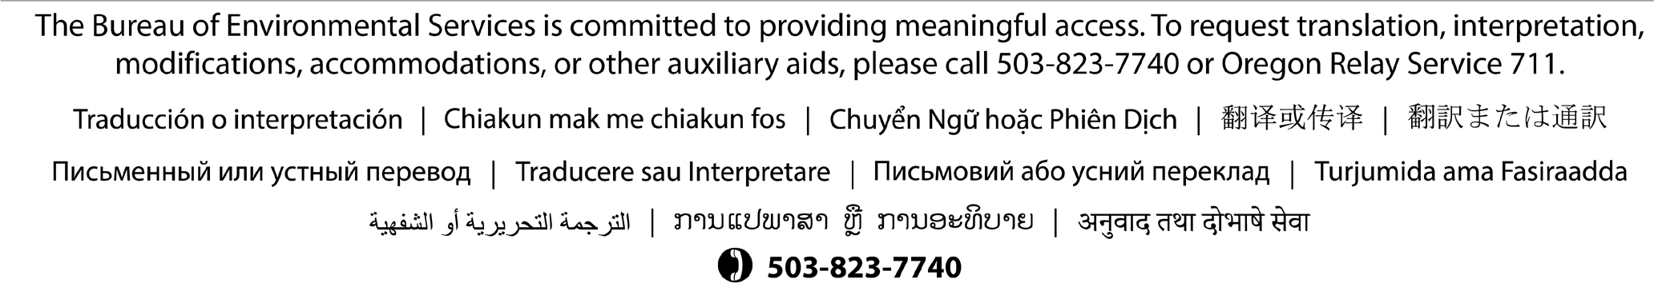

B. Project Information
Project Name:
Project Location (address or closest street and cross street):
Estimated CWSP grant request ($12,000 maximum):
Check the watershed(s) in which the project is located in.  - Fanno Creek  - Tryon Creek  - Johnson Creek  - Columbia Slough  - Willamette River  - Columbia River  - Unsure | Project Categories  (please select all that apply):  - Pavement Removal and Urban Restoration  - Cleanup Projects  - Natural Area Restoration  - Environmental Education and Art  - Rain Gardens and Stormwater Management  - Youth Leadership  - Community Garden  - Other: | Check the region of the city in which the project is located.  - N Portland  - NE Portland  - NW Portland  - Outer East Portland  - SE Portland  - SW Portland
B1. Briefly describe your organization and your fiscal agent (if applicable).

B2. Describe the specific project you wish to undertake with stewardship funds during grant cycle JULY 2024 THROUGH JUNE 2025 (Funds available after fully activated contract).

B3. Describe what has been done on the project since submitting the pre-application materials.

B4. Describe the current and proposed role of project coordinator(s).

B5. Describe your plan for continued community involvement and long-term maintenance, if applicable. Who will be responsible for monitoring the project site or assessing the needs of the project after the funding period has ended, if applicable?

- Project Benefits (based on grant selection criteria – See Grant Guide)

Section I: Watershed Benefits
C1. Describe the general environmental or watershed health benefits expected from this project.

C2. Describe the educational elements of this proposal, including what people involved will learn about the environment, watershed health and stewardship.

Section II: Community Involvement and Partnerships
C3. Describe the community benefits expected from this project. How will the neighborhood/community and individuals involved in the project benefit?

C4. List the groups that have committed to working on your project and describe how they will be involved (volunteer labor, in- kind donations, etc.). Be sure to provide letters of support from these groups, and account for their contributions in the project budget.

Section III: Equity and Leadership of Underrepresented Communities
C5. Explain how your project helps CWSP meet its goal of promoting equity and the leadership of underrepresented communities, as described in the Grant Guide.

- Project Timeline

Timeframe | Tasks | Parties Responsible
Ex. Fall 2024

- Budget Narrative
E1. Please explain the details about your budget. In terms of Professional Services, describe who will be doing the work and if they are a contractor (with their own business and insurance), staff, temporary staff, interns, volunteers, etc.

F. Project Budget

Project Name:
Activity/ Expense | CWSP  Funds | In-kind donations and other funding | Source of Match | Comments |  | Totals
Materials and Supplies
Plants | $ | $ |  |  |  | $
Mulch | $ | $ |  |  |  | $
Rentals | $ | $ |  |  |  | $
Tools | $ | $ |  |  |  | $
Erosion Control | $ | $ |  |  |  | $
Dropbox Rental and Disposal | $ | $ |  |  |  | $
Other (specify) | $ | $ |  |  |  | $
Refreshments ($500 max)
Work Party Snacks | $ | $ |  |  |  |  | $
Staff/Professional Services
Project Coordinator | $ | $ |  |  |  |  | $
Youth Compensation | $ | $ |  |  |  |  | $
Contracted Services | $ | $ |  |  |  |  | $
Administrative Fees | $ | $ |  |  |  |  | $
Insurance | $ | $ |  |  |  |  | $
Permits | $ | $ |  |  |  |  | $
Other (specify) | $ | $ |  |  |  |  | $
Volunteer Labor |  | Hours (estimate) |  |  | Comments
Student Volunteers |  |  |  |  |  |  | $
Adult Volunteers |  |  |  |  |  |  | $
Professional Volunteers |  |  |  |  |  |  | $
Volunteer Project Coordinator |  |  |  |  |  |  | $
Total for Grant Project | CWSP  Total | Matching Total |  |  |  |  | Project Total
 | $ | $ |  |  |  |  | $

Note: Suggested line items are provided here. These may be amended for your particular project, but please retain the blue category labels. Total CWSP budget may not exceed $12,000.
WS2031 NOV 2023

